

**Capstone Project**

**Marketing-Airplane Passenger Satisfaction Prediction**



**by**

**duchoma ojong agoons**

**Table of Contents**

**Executive Summary** 3

**Problem Description** 3

**1** **Background of study** 4

**1.2** **​Statement of the Research Problem** 6

**1.3** **Analytical Problem** 7

**1.4** **Final insights and recommendations** 7

**1.5** **Implications and Scope of the Study** 10

**1.6** **Limitation of study** 10

**2.** **Data Report** 11

**2.1** **Methodology** 11

**2.1.1**  **Importing the dataset in R** 12

**2.1.2**  **Number of Rows and Columns:** 13

**2.1.3 Names of columns** 13

**2.1.4** **Missing Value Identification** 14

**2.1.5** **Dataset summary** 15

**2.1.6** **Structure of data** 17

**2.1.7** **In-depth view of the flight data together with satisfaction variable** 17

**Where does the airline stand?** 19

**3.1** **Univariate Analysis** 19

**3.1.1 Correlation matrix** 24

**3.1.2 Exploratory analysis** 25

**3.2**  **Bivariate Analysis** 26

**3.2.1** **Relationship between variables** 28

**3.2.2** **Where does Falcon Airline stand with respect to customer groups; segmenting survey data by flight data** 42

**Correlation and histogram plots** 54

**Relationship between Categorical data** 55

**Relationship between numerical and categorical variables** 59

**Treatment of missing observations from data** 60

**Train and test splits** 60

**Classification and regression tree (CART)** 61

**Variables of importance printed by the software** 66

**Model performance measures** 67

**Customer Segmentation** 68

**Clustering algorithm: partitioning around medoids (pam)** 69

**Visualization in a lower dimensional Space** 72

**Summary of clusters** 73

**Random Forest Model** 77

**Model performance measures** 79

**Recommendations for decision making** 82

**3.3 References** 87

# **Executive Summary**

# **Problem Description**

This is the dilemma of a reputed US airline carrier ‘**Falcon airlines’**. They aim to determine the relative importance of each parameter with regards to their contribution to passenger satisfaction. Provided is a random sample of 90917 individuals who travelled using their flights. The on-time performance of the flights along with the passengers’ information is published in the csv file named ‘Flight data’.  These passengers were asked to provide their feedback at the end of their flights on various parameters along with their overall experience. These collected details are made available in the survey report csv labelled ‘Survey data’. In the survey, the passengers were explicitly asked whether they were satisfied with their overall flight experience and that is captured in the data of survey report under the variable labelled ‘Satisfaction’.

The two objective of this project are-

1. To understand which parameters play an important role in swaying a passenger feedback towards ‘satisfied’?

2. To predict whether a passenger will be satisfied or not given the rest of the details are provided.

**Dataset**

The problem consists of 2 separate datasets: Flight data & Survey data. The flight data has information related to passengers and the performance of flights in which they travelled. The survey data is the aggregated data of surveys collected post service experience. You are expected to treat both the datasets as raw data and perform any necessary cleaning/validation steps as required.

# **Background of study**

The concept of customer value has been examined by numerous authors from different perspectives. Although so many authors have examined customer value from different perspectives and come with various definitions, there are two common themes in most definitions of value: the notions of ‘‘trade-off’’ and ‘‘benefit-sacrifices’’. There was a debate as to what should be included as benefits of a product, which some researchers suggested should be the product’s “quality” and others suggested it should include much more than just quality. And what should be included as the cost of a product. Thus, the most summarized of the definitions of customer value is that of Weinstein (2012) which is defined as trade-offs between benefits received from offers versus the sacrifices including money, stress, and time to obtain products and services or these offers.

​In today’s highly competitive market environment where companies have equal or great opportunities to access the same resources including talents, technology, and information, the question, if not superior customer value, then what else do companies have to offer consumers? Companies today must seek more than ever before to distinguish themselves and the ability to do so using technology. The availability of means and resources is no longer a viable strategy for differentiation or distinction. Therefore, they must turn to customer value which makes all the difference between companies offering similar products and services. Superior customer value serves as the most unique strategic option for differentiation in an environment where most companies are market followers rather than market leaders. Companies that deliver above and beyond customers’ expectations by overwhelming and surprising customers stay way ahead of their competitors and command the greatest profits and market share (Weinstein, 2012).

Customer value is important for business success (McDougall and Leveque, 2000; Spiteri and Dion, 2004).The source of superior customer value can be identified from organizational resources and capabilities, such as human resource management, innovation, knowledge management, organizational culture and structure (Mittal and Sheth, 2001; Walter and Jones, 2001; Weinstein and Pohlman, 1998). Discuss about the airline company in brief. Creating customer value has a positive impact on stakeholders, i.e. customers (Eggert and Ulaga, 2002; Oh, 1999; Woodruff, 1997), employees, and shareholders (Mittal and Sheth, 2001) and ultimately, the government. Satisfied customers are more likely to repurchase the product/services (Baker and Crompton, 2000; Patterson and Spreng, 1997; Oh, 1999), and spread positive word of mouth (Petrick, 2002).

In the long-run, organizations that are successful in maintaining delivery of superior value build customer loyalty (McDougall and Leveque, 2000) and customer retention (Flint et al., 1997) both of which drive up shareholder value (Mittal and Sheth, 2001).

# **1.2 ​Statement of the Research Problem**

Customer value has been of major concern to businesses in recent years. Almost every field of studies, such as: economics, social science, accounting, finance, strategy, product management, information system, and marketing, has addressed this issue (Huber et al., 2001; Ulaga and Chacour, 2001). Customer value has two perspectives; customers’ perspective and service provider’s perspective. These perspectives are likely to differ (Saleh and Ryan, 1991). The interpretation of the word “value” is subjective (Sweeney and Soutar, 2001). According to McFarlane and Britt (2007), the marketing environment of today has changed dramatically, and companies must effectively devise strategies for responding to, and dealing with this change, while ensuring maximum customer value and satisfaction. Key success factors (KSFs) are no longer unique to any company. All businesses today must have a certain and minimum degree of financial well-being, innovation, quality, value, image, customer knowledge, technology, and understanding of their products and markets. What remains unique and becomes an ultimate competitive advantage or factor for market leadership is how companies deliver on their value propositions (Weinstein, 2012). The design and delivery of customer value must be superior to that of their competitors, and this is not easily achieved without developing a customer centric philosophy and culture within the organization. This entails engendering a market orientation with customers as the focus of all organizational activities, decisions, and processes – meeting customer needs and wants must essentially become the major value driver within the organization and each member of the organization must understand this and become a value adding knowledge worker with a passion for customer service and satisfaction.

Given that key success factors are no longer unique to any company, and what is of utmost importance is creating and delivering superior customer value to customers, the main question that pops up in our mind is that of “**how can we design and deliver superior customer value so that Falcon airlines will not only increase its market share but will become the market leader in the airline industry?**”

# **1.3 Analytical Problem**

The analytical problem in this case is a classification problem; we need to predict whether or not a passenger will be satisfied or not. Using a classification model, we will be able to predict which variables are more important in predicting satisfaction or dissatisfaction. We focused on the four pillars of analytics to solve this problem; **descriptive analytics**, which seeks to understand what the data tells us about where Falcon data stands with respect to its customers. Next, **diagnostic analytics** seeks to understand why the observations in descriptive analytics. Then, **predictive analytics** sought to build a model to predict customer satisfaction and finally, **prescriptive analytics** which outlined recommendations for decision making.

# **Final insights and recommendations**

The overall satisfaction of customers is 55%. Our decision tree is revealed the following for the entire customer size of study:

1. Those who rate **in-flight entertainment < 4** have an overall satisfaction of 22% while those who rate it greater than 4 have an average satisfaction of 82% and 55% of customers fall in this bucket. Thus, inflight entertainment is the most important driver for customer satisfaction.

**Recommendation:**

* Improve entertainment for all classes of travel. Prior analysis revealed o us that younger customers and those between [70, 85] are very demanding on entertainment. Falcon Airlines should prepare various entertainment packages for all age groups.
* Falcon Airlines can partner with the entertainment industry to share some useful intelligence on what the various age demographics care about.

1. Customers who rate **in-flight entertainment > 4** and rate and also rate **Ease of online booking** > 4 have an overall satisfaction of 90% compared to those who rate **Ease of online booking** < 4. Thus, **ease of online booking** is the second most important driver of customer satisfaction.

**Recommendation:**

* Falcon Airlines should make online booking such that it is perceived as easy by the customers.
* Falcon Airlines should make the online booking technology user friendly.

1. If people are rating **in-flight entertainment** as bad and are also rating **Seat comfort** as bad, then, their satisfaction rate is 15% but those rating seat comfort as good have a satisfaction rate of 71%. Thus, **seat comfort** is the third most important driver of customer satisfaction.

**Recommendation:**

* Seat comfort should be improved for economic and economic pro classes.
* Seat comfort should be improved on Falcon Airlines’ aircrafts in general.

1. Customers’ rating **online boarding** as good have an overall satisfaction of 65% while those rating it as bad have an overall satisfaction rate of 34%.

**Recommendation:**

* The technology used by Falcon Airlines should be user friendly and also online support should be very effective.

1. Finally, customers not happy with inflight entertainment, seat comfort and food and drinks have an overall satisfaction rate of 10% while those not happy with inflight entertainment, seat comfort but are happy with **food and drinks** have an overall satisfaction rate of 68%.

Digging deeper, we found the profile of customers and their age groups after segmentation and based on observations made from the data, appropriate recommendations were further made. A stratified sample, representing 10% of our dataset was used to cluster and segment our population. We summarized the findings and profiled customers as follows

|  |  |  |  |  |  |  |
| --- | --- | --- | --- | --- | --- | --- |
| Clusters | Gender | Customer Type | Type Travel | Class | Satisfaction | Age Bins |
| 1 | Female | Loyal customers | Business travel | Business | Satisfied | (49,60] |
| 2 | Female | Loyal customers | Business travel | Business | Dissatisfied | (29,49] |
| 3 | Female | Disloyal | Business travel | Eco | Dissatisfied | (19,29] |
| 4 | Female | Loyal | Business travel | Business | Satisfied | (29,49] |
| 5 | Male | Loyal customers | Business travel | Business | Satisfied | (29,49] |
| 6 | Male | Loyal customers | Personal travel | Eco | Dissatisfied | (29,49] |
| 7 | Female | Loyal customers | Personal travel | Eco | Satisfied | (29,49] |
| 8 | Male | Loyal customers | Personal travel | Eco | Dissatisfied | (29,49] |

Above all, training of employees is critical as backed by the qualitative research.

# **1.5 Implications and Scope of the Study**

The practical implications of this research will be to study how to create customer value and give a promotional strategy for the company.

# **1.6 Limitation of study**

The data for this study was collected post service experience. The question of over which period of time and how frequent the data was collected cannot be answered given the limited information at our disposal.

# **2. Data Report**

# **2.1 Methodology**

For this project, we followed the following methodology: we began by understanding the current situation of where Falcon Airlines stands and we used the data available to us to tell us this. We used several algorithms in this phase like summary measures, histograms for pattern recognition, boxplots, correlation plots, linear regression and chi-squared tests.

After having understand where Falcon Airlines stands with respect to its customers, we sought to understand why the above observations. We built hypotheses and made some conjectures.

In the third major step, we sought to predict whether or not a customer would be satisfied post flight aboard Falcon Airlines and the factors responsible for swaying a customer’s choice of satisfaction or dissatisfaction. We used decision trees and random forest algorithms to do this prediction. This led us to create a 10% stratified sample of our data, on which we ran a partitioning around medoids (PAM) clustering algorithm, profile the various customer segments to find drivers of satisfaction for the different segments of the population.

Finally, we made some recommendations for decision making.

In more detail, the following steps were carried out:

1. Importing the dataset in R
2. Understanding how data was collected in terms of time, frequency and methodology
3. Visual inspection of data (rows, columns, descriptive details)
4. Understanding of attributes (variable information, renaming of variables if required)
5. Initial Exploratory data analysis
6. Understanding the structure of dataset
7. Checking for missing variables
8. Graphical explorations and visualizations
9. Descriptive statistics
10. Univariate analysis (distribution and spread for every continuous attribute, distribution of data in categories for categorical ones)
11. Bi-variate analysis (relationship between different variables , correlations)
12. Imputation for missing variables
13. Model building
14. Clustering and segmentation
15. Prescriptive statistics (recommendations for decision making)

# **2.1.1 Importing the dataset in R**

The survey data had Likert scale like responses; 0=extremely poor, 1=poor, 2=need improvement, 3=acceptable, 4=good and 5=excellent. All the variables, ‘Seat comfort’, ‘Departure/Arrival time convenient’, ‘Food and drink’, ‘Inflight wifi service’, ‘Inflight entertainment’, ‘Online support’, ‘Ease of Online booking’, ‘On-board service’, ‘Leg room service’, ‘Baggage handling’, ‘Checkin service’, ‘Cleanliness’, and ‘Online boarding’, had the above scaling but for the ‘Gate location’ variable which had as scaling responses; 0=very inconvenient, 1=inconvenient, 2=need improvement, 3=manageable, 4=convenient, 5=very convenient. However, the scaling of the variables was considered as one for the sake of analysis.

We converted the Likert scale to their corresponding numerical numbers using the “Find and Replace” function in excel. We then merged the converted survey data to the Flight data, which contains passengers’ data. The data was then imported in R.

# **2.1.2 Number of Rows and Columns:**

* The number of rows in the dataset is 90917
* The number of columns in the dataset is 24.

# **2.1.3 Names of columns**

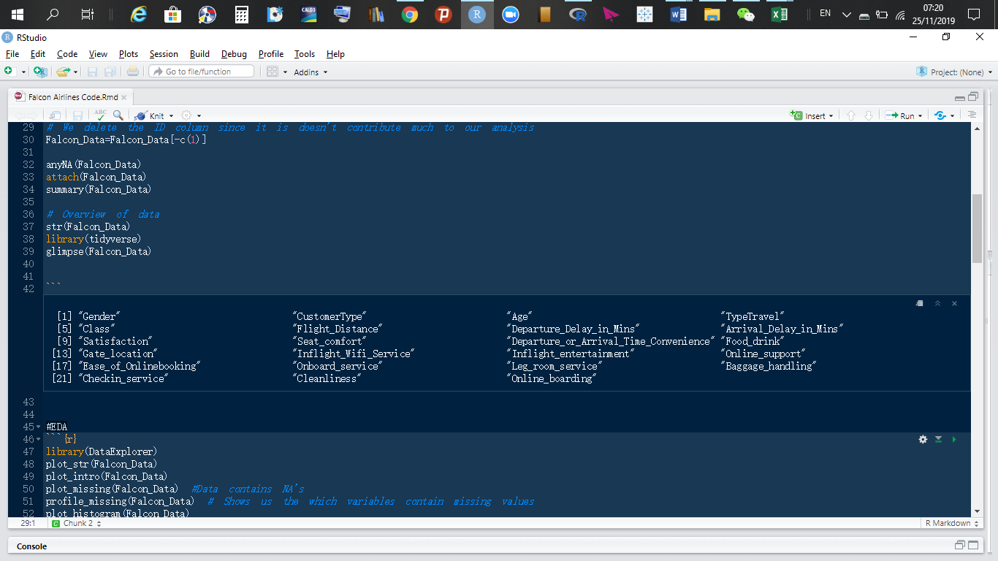

# **2.1.4 Missing Value Identification**

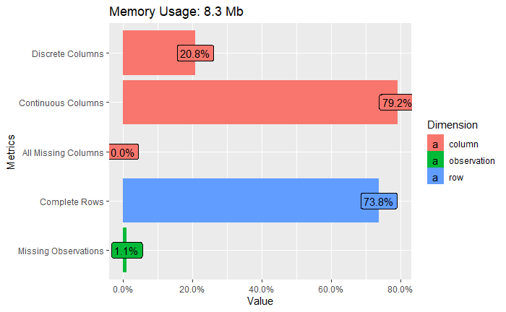

*Chart 1.2a*

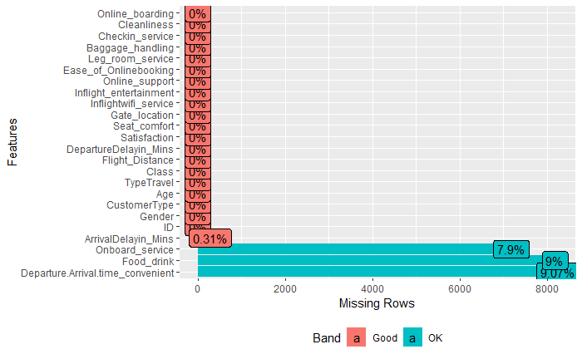

*Chart 1.2b*

**Observations:**

* The following variables: **Onboard_service**, **Food_drink**, and Departure_Arrival_time_convenience all have a pattern of NA’s; meaning customers did not respond to this questions. All the questions were optional but customers chose not to fill them.
* Charts 1.2a and 1.2b indicate that there are some missing values in the rows and columns of our dataset. Specifically, Arrival_Delayin_Mins variable contains 0.31% of NA’s in its column. On-board service variable has 7.9% of NA’s. Food and drink variable contains 9% of NA’s, and Departure_or_Arrival_time_convenience variable contains 9.07% of NA’s in its rows.
* From our analysis, we found that **Departure_Arrival_time_convenience** swayed respondents’ ratings on many of the questions. Delays caused respondents’ to rate other questions poorly due to their dissatisfaction.

# **2.1.5 Dataset summary**

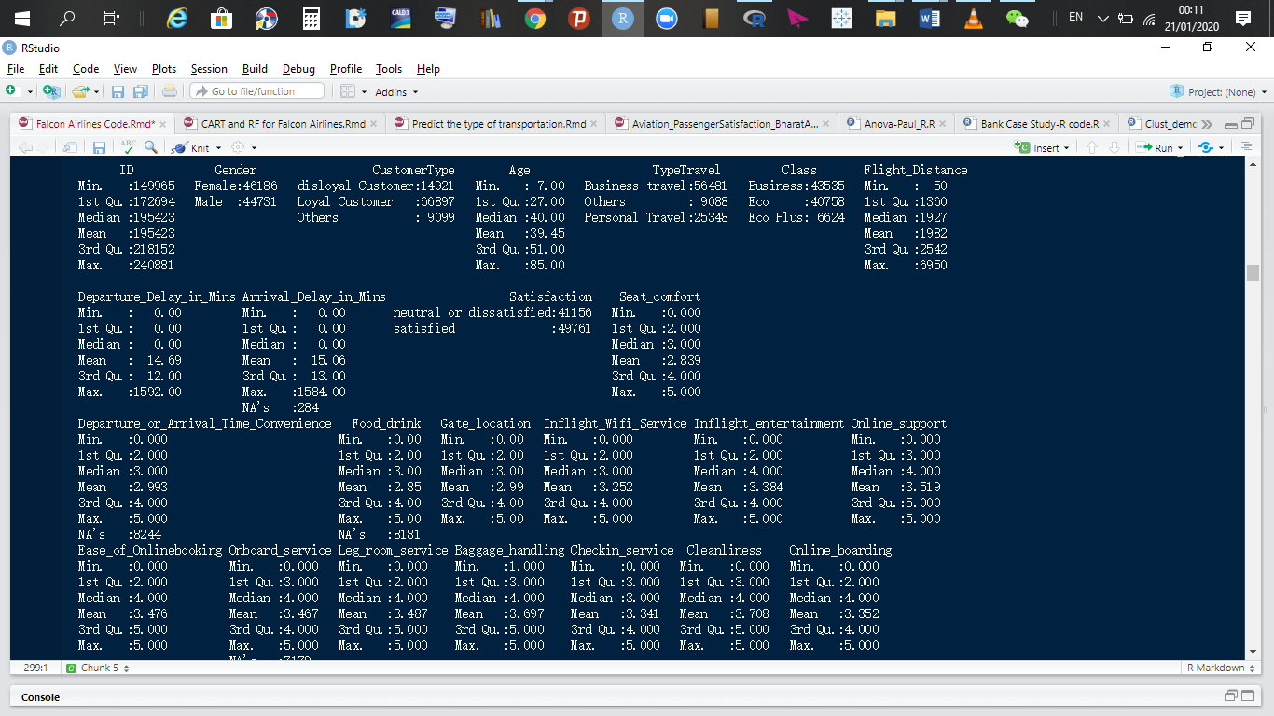

* From the summary of our data, we see that there are slightly more female than male passengers.
* There are approximately 74% loyal customers, 16% disloyal customers and 10% of customers are independents.
* Customers’ Age ranges from 7 to 85.
* 62% of customers travel for business purposes, 28% of customers travel for private reasons, and approximately 10% of the remaining customers travel for other reasons.
* Approximately 48% of these clients travel with business class. Approximately 45% of customers travel economy class. The remaining 7% travel with Economy plus class.
* The flight distance ranges from 50 miles to 6950 miles.
* The maximum departure delay period is 26.5 hours, more than a day, and the median waiting times is zero minutes, which tells us that, most of Falcon airlines’ flights take off on time. A similar delay is experienced with arrival times.
* Approximately 55% of customers are satisfied with Falcon airlines while 45% are not. These 45% unsatisfied or neutral customers are likely to move to competitors if competitors deliver on value.
* Our data contains some NA’s or customers did not provide answers to some questions in the survey data.
* **CustomerType** and **TypeTravel** variables contain an unlabeled category. We need to clean the data.

# **2.1.6 Structure of data**

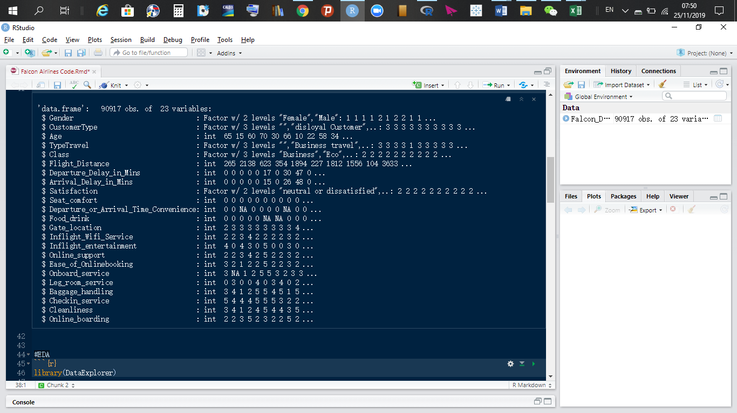

# **2.1.7 In-depth view of the flight data together with satisfaction variable**

1. Gender

Value Female Male

Frequency 46186 44731

Proportion 0.508 0.492

1. CustomerType

Value Neutral Disloyal Customer Loyal Customer

Frequency 9099 14921 66897

Proportion 0.100 0.164 0.736

1. Age

lowest : 7 8 9 10 11, highest: 77 78 79 80 85

1. TravelType

Value Other Business travel Personal Travel

Frequency 9088 56481 25348

Proportion 0.100 0.621 0.279

1. Class

Value Business Eco Eco Plus

Frequency 43535 40758 6624

Proportion 0.479 0.448 0.073

1. Flight Distance

Mean Gmd .05 .10 .25 .50 .75 .90 .95

1982 1145 341 544 1360 1927 2542 3398 3833

lowest : 50 51 52 53 54, highest: 6889 6907 6924 6948 6950

1. Departure_Delay_in_Mins

Mean Gmd .05 .10 .25 .50 .75 .90 .95

14.69 24.48 0 0 0 0 12 43 76

lowest : 0 1 2 3 4, highest: 978 1017 1128 1305 1592

1. Arrival_Delay_in_Mins

Mean Gmd .05 .10 .25 .50 .75 .90 .95

15.06 24.95 0 0 0 0 13 44 78

lowest : 0 1 2 3 4, highest: 970 1011 1115 1280 1584

1. Satisfaction

Value neutral or dissatisfied satisfied

Frequency 41156 49761

Proportion 0.453 0.547

# **Where does the airline stand?**

# **3.1 Univariate Analysis**

1. **Cleanliness:**

**Observation**

* More than 60% of customers think the aircraft is clean and excellent.
* A growing percentage of customers think are of the opinion that the aircrafts need improvement with respect to cleanliness and others think that cleanliness is poor.

**Recommendation**

* Continuously monitor the state of aircrafts.

1. **Online boarding:**

**Observation**

* More than 50% of clients are of the opinion that online boarding is okay, specifically, 23.1% of clients say it is excellent, 27.1% say online boarding is good and another 23.6% are of the opinion that online boarding is acceptable.
* 25% of customers think this service is poor and thus needs improvement.

**Recommendation**

* In order to be the market leader, Falcon airlines should strive to be in the “good” and “excellent” range for at least 70% of its customers. Since innovation is the price for survival, Falcon airlines needs to improve on cleanliness and online boarding services since a growing population of its clients care about it.

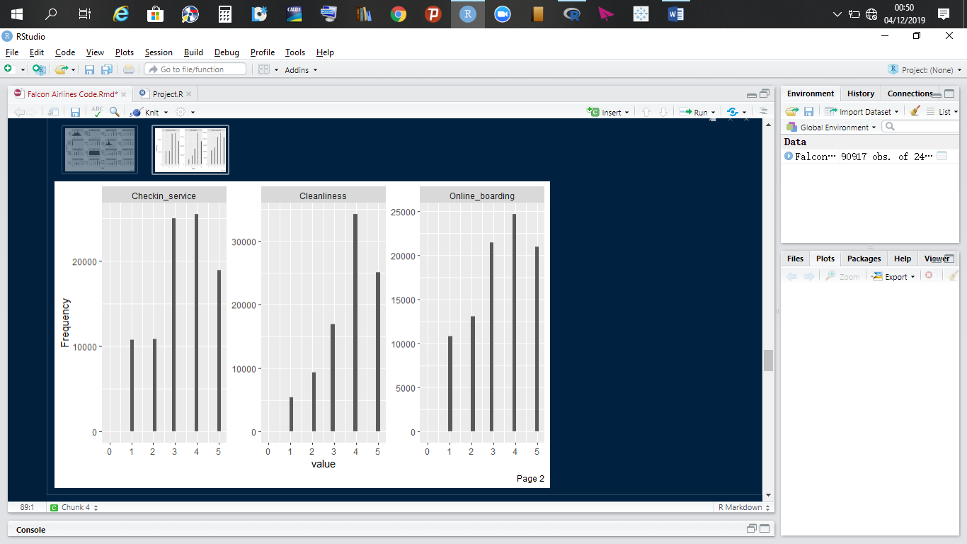

1. **Age**

**Observation**

* The Age variable is normally distributed with the lowest customers’ age being 7, 8, 9, 10, and 11 and the highest customers’ age being 77, 78, 79, 80, and 85.
* Between the age ranges of 7 to 22, there are more young people travelling than between the age group of 70 to 85.
* Majority of customers are between the age ranges of 25 to 60, with a mean age of 39.45. The Age Bins will shine more light on customers’ age categories.

1. **Age Bins**

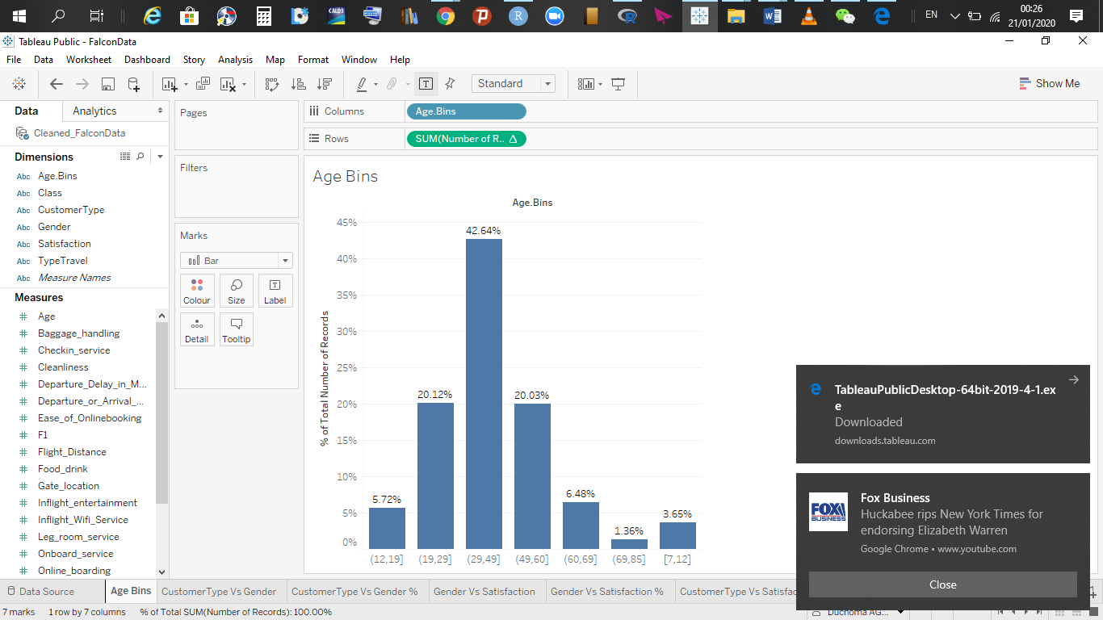

**Observation**

* Most of the airlines’ passengers are between 30 to 49 years old. They make up 42.6% of the airlines customers. During segmenting of customers, we will suggest some actions to take to preserve these customers.
* Age group (70, 85] contains the least group of customers for Falcon airlines.

1. **Departure delay and Arrival delay (in minutes)**

**Observations:**

* The majority of Falcon airlines’ flights are on time as shown by the **Arrival_Delay_Time_in_Mins** and **Departure_Delay_in_Minutes** variables.
* They have a median value of zero, which confirm that most flights are on time.
* There are some exceptions by the way. The lowest delays times are 0, 1, 2, 3, and 4 minutes respectively. The highest delays times are 970, 1011, 1115, 1280, and 1584 minutes respectively. A similar pattern is experienced with **Departure_Delay_in_Minutes.**

1. **Baggage handling**

**Observations**

* Overall, more than 50% of customers are of the opinion that baggage handling is good; 37% of customers are of the opinion that bagging handling is good and 27% are of the opinion that it is excellent.
* Some improvements need to be made because there is a growing percentage of customers who think it is not only poor, but, extremely poor.

**Recommendation**

* Falcon airlines should make sure luggage have no scratches, they arrive on time and they should take measures to prevent the loss of customer luggage.

1. **Departure or arrival time convenience**

**Observation**

* Though some customers are have no problem with this, a growing population of customers think it is not only poor but extremely poor. We will investigate further which particular customer groups don’t like this.

1. **Ease of online booking**

**Observation**

* Online booking is quite good. However, 25% of customers are not very pleased with this service.

f) **Flight distance, Food and drinks, gate location, inflight entertainment and inflight Wi-Fi service**

**Observation**

* Flight distance variables is normally distributed.
* Food and drinks, inflight entertainment, inflight wifi service and gate location, are overall good. However, they need improvement.

1. **Leg room service**

**Observation**

* Majority of the customers are of the opinion that check in service is good. 22% of customers are not satisfied with the check in service and thus, improvements need to be made.

1. **Delay or arrival time**

**Observation**

* Majority of the customers are of the opinion that delay or arrival time is just okay on average. However, 30% of customers are not very pleased with this. Approximately 5% of customers are of the opinion that this is extremely poor.

In general, Falcon airlines’ services are on average well rated by a majority of their customers. However, there is approximately more than 20% of their customers who are of the opinion that these services need to be improved.

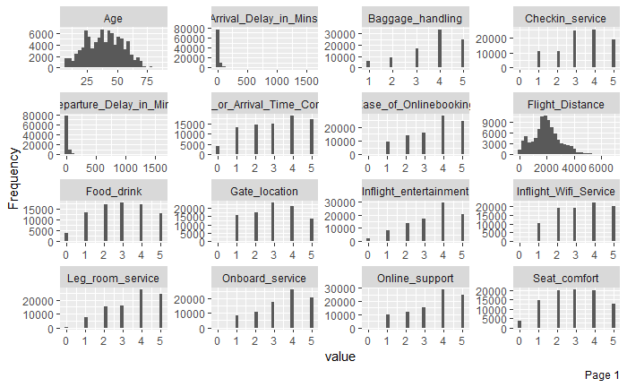

# **3.1.1 Correlation matrix**

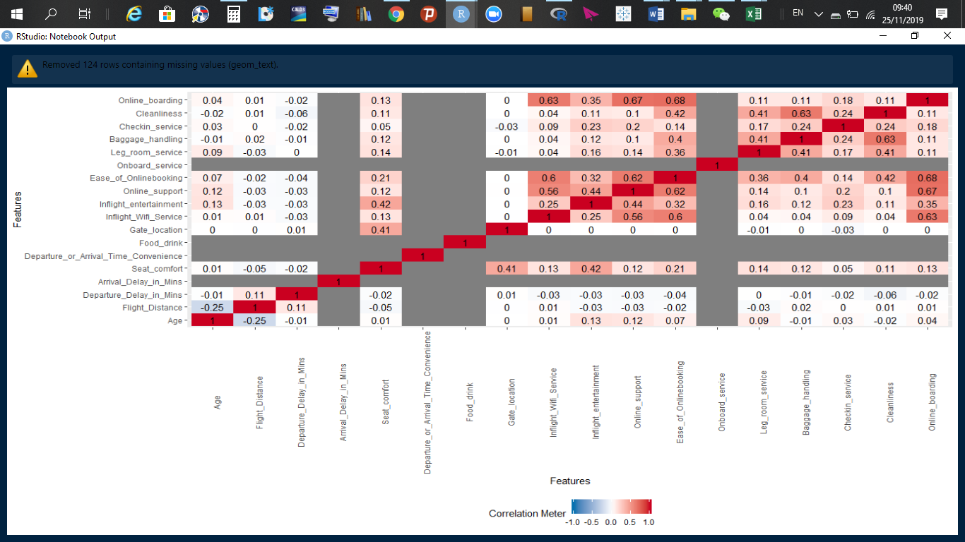

**Observation**

* There exists moderate correlations between ease of online booking with online support. Majority of the correlations observed are not actionable. This is because our data contains so many NA’s.

# **3.1.2 Exploratory analysis**

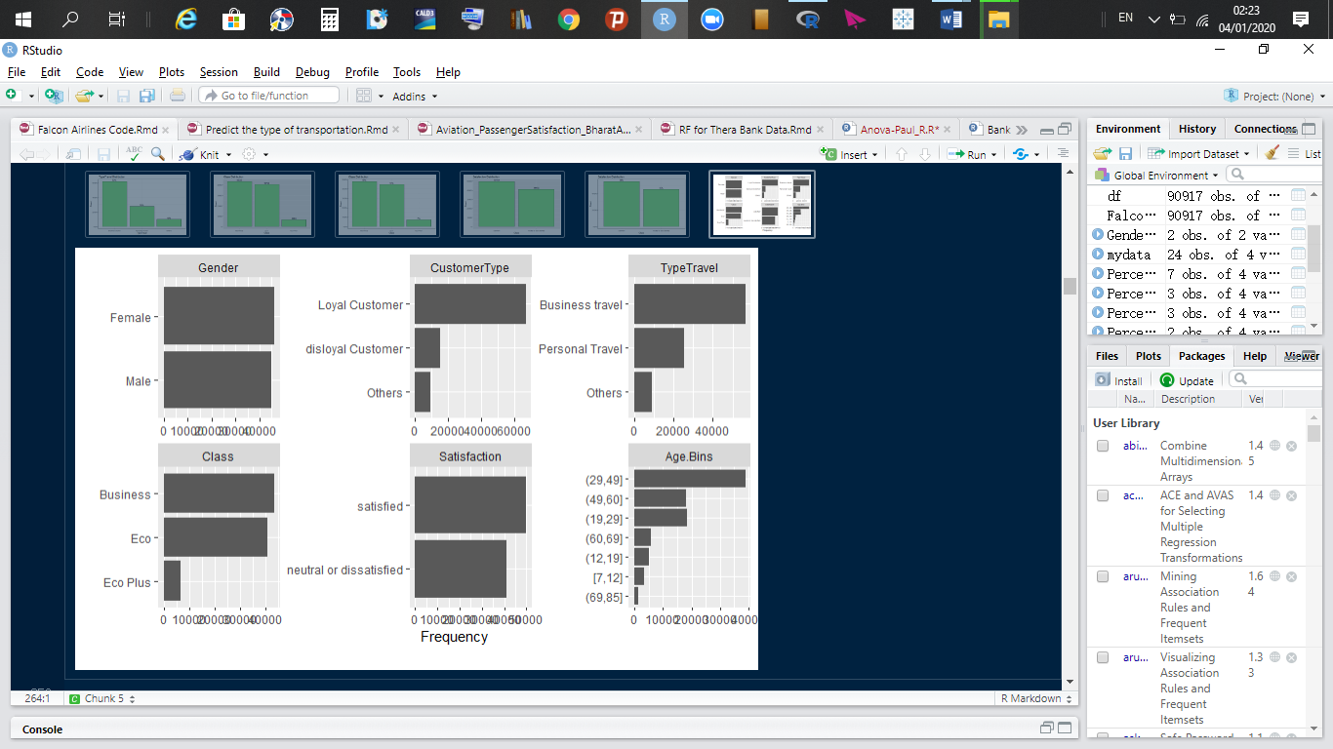

Falcon airlines has a record number of loyal customers. Most of its customers travel for business purposes and they mostly travel by business and Eco class. Overall, though the majority of their customers are satisfied, there is a 45% of them who are not satisfied and this number is very significant.

Most of the airlines’ passengers are between 30 to 49 years old. They make up 42.6% of the airlines customers. They mostly travel for business purposes. Age group (69, 85] contains the least group of customers for Falcon airlines.

# **3.2 Bivariate Analysis**

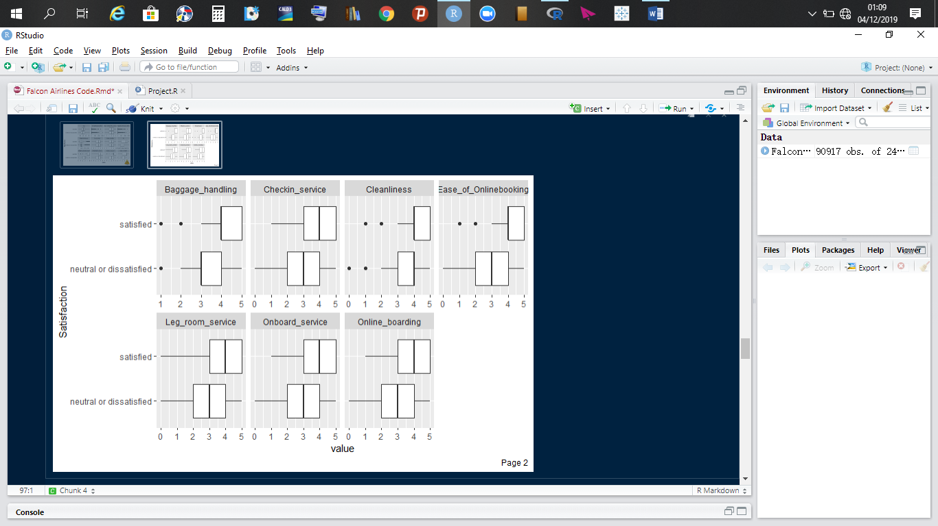

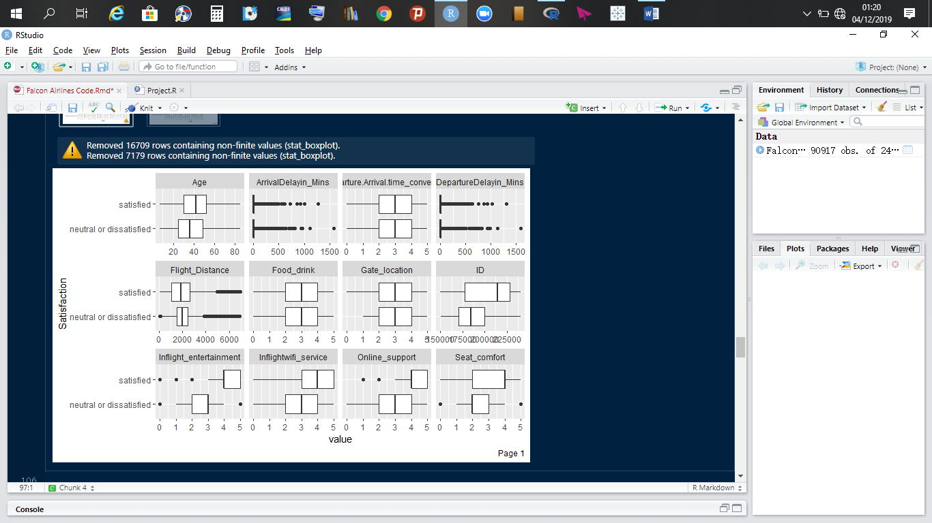

**Observations**

* The median age of dissatisfaction customers is lower than that of satisfaction customers.
* Dissatisfied customers travel for slightly longer distances than satisfied customers.
* There is a differentiation in the satisfaction-dissatisfaction rating in the following variables: Baggage handling, inflight entertainment, inflight wifi service, online support, seat conform, check-in service, cleanliness, ease of online booking, leg room service, onboard service, and onboard boarding are rated “good” by satisfied customers.
* The satisfaction-dissatisfaction difference is very close with some parameters. Thus, there is a risk that more customers will be dissatisfied and might move to competitors in search of value

# **3.2.1 Relationship between variables**

**CustomerType Vs Gender**

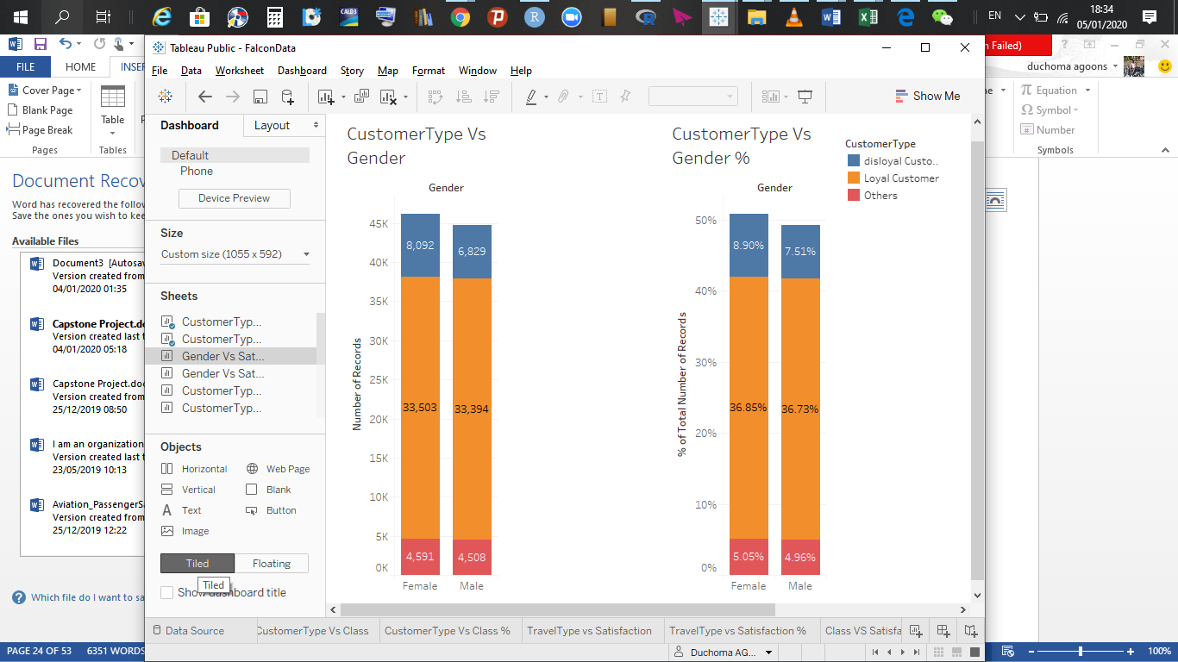

**Observation:**

* The percentage of females’ customers is slightly higher than that of males for all customer type categories.

**Gender vs Satisfaction**

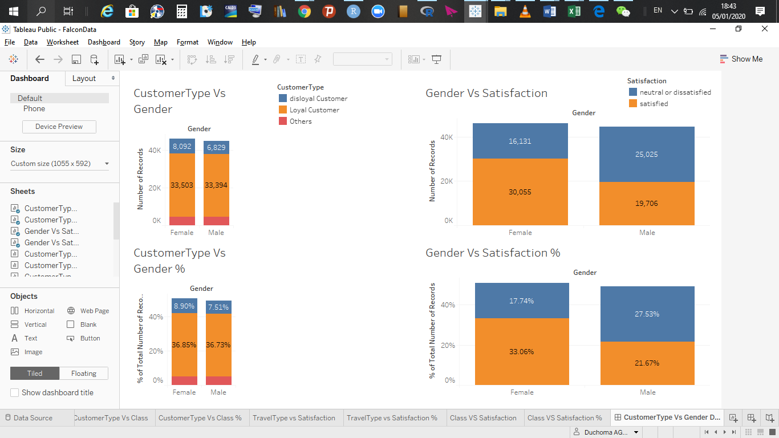

**Observation:**

* 33.06% of female customers are satisfied while 17.74% are not.
* More male customers are dissatisfied than satisfied. **Why?**
* More females are satisfied than males. Males should have a high expectancy from the airline company or the drivers for satisfaction for males differ from that of females.

1. **CustomerType Vs Satisfaction**

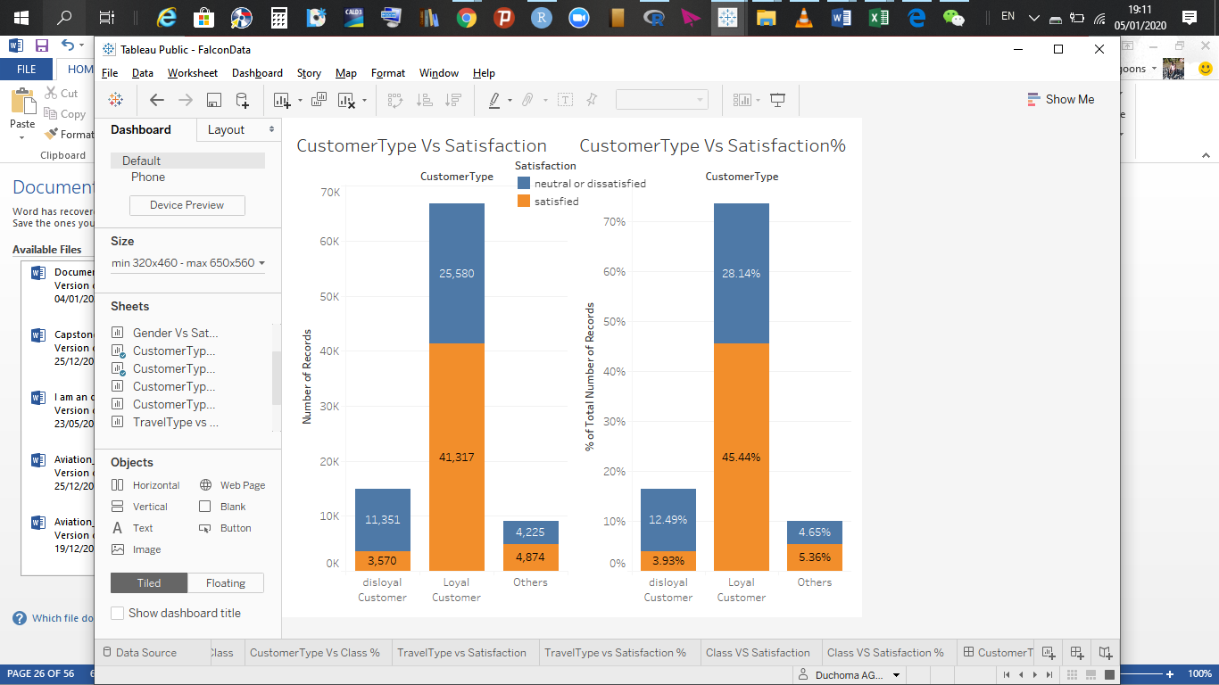

**Observation**:

* 45.44% of loyal customers are satisfied while 28.14% are dissatisfied.
* 3.93% of disloyal customers are satisfied while 12.49% are dissatisfied. Thus, disloyal customers are overwhelmingly unsatisfied and may move to the competition.
* Unlabeled customer cluster are dangling in between satisfaction and dissatisfied or neutral.
* For other customers, overall, they are satisfied but the satisfaction - dissatisfaction margin is too narrow.

**Customertype Vs Class**

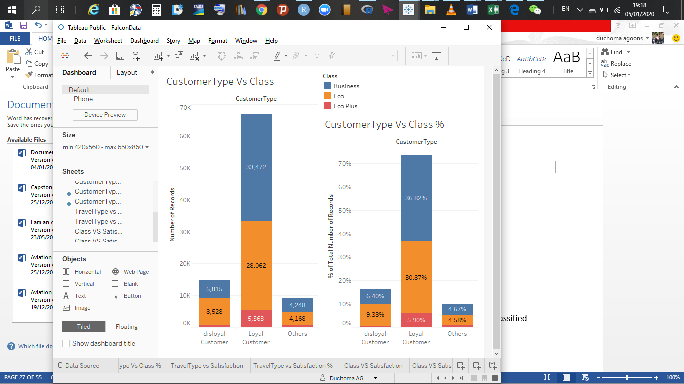

**Observation:**

* Disloyal customers on average travel using Eco class. Loyal and unclassified customers on average use all three classes in the same proportion.
* 36.82% of loyal customers fly business, 30.87% of them fly Eco, and 5.90% of them fly Eco Plus class.
* 6.40% of disloyal customers fly business, the majority of disloyal customers fly Eco class (9.7%), and 0.6% of them fly Eco Plus.
* The majority of ‘other’ customers travel using Business and Eco class.
* In general, 47.89% of customers fly using business class. **This class should be improved tremendously for every aspect of questions asked to the clients.**

**TypeTravel Vs Satisfaction**

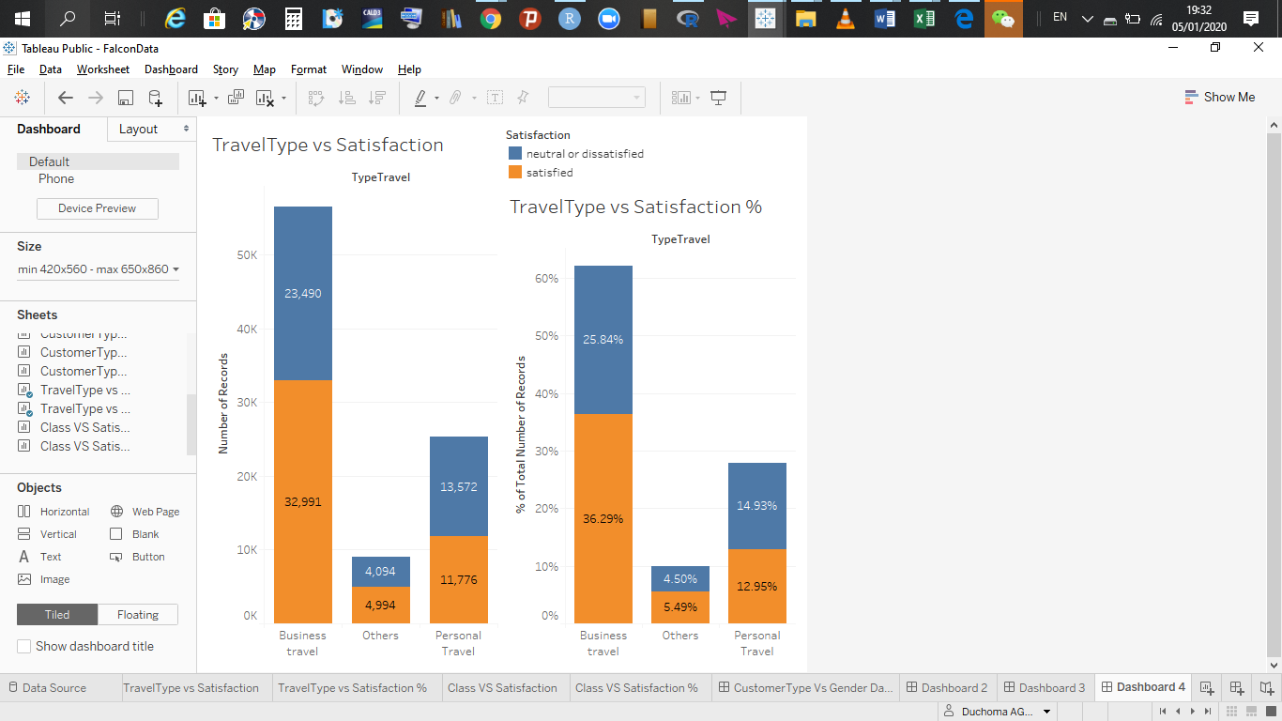**Observation:**

* The majority of business class travelers are satisfied.
* 36.29% of business class travelers are satisfied while 25.84% are dissatisfied. **Given that the 47.89% of customers fly using business class, this is of great concern.**
* The majority of personal type travelers are not satisfied (14.93%) while 12.95% are satisfied.
* The satisfaction-dissatisfaction percentage of ‘Others’ is very narrow.

1. **Class Vs Satisfaction**

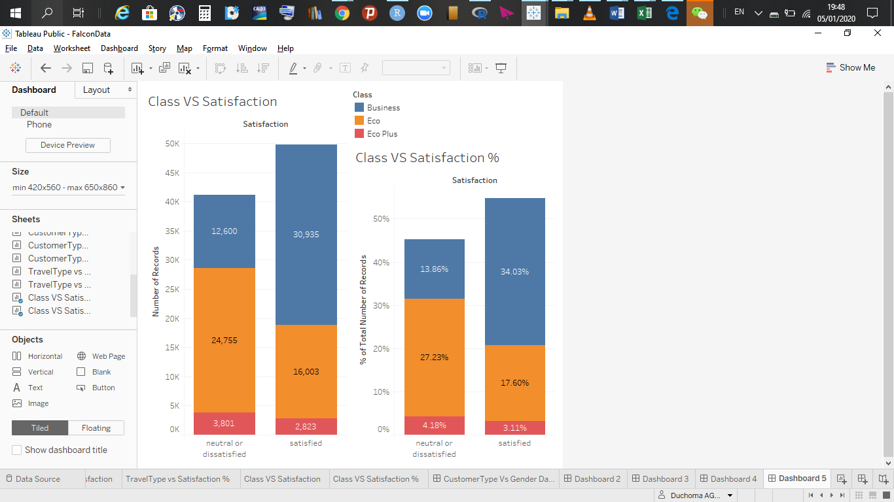

**Observation:**

* The majority of business class travelers are satisfied (34.03%), while 13.86% are dissatisfied.
* 27.23% of Eco class passengers are not satisfied while 17.6% are.
* The majority of Eco Plus (4.1%) passengers are dissatisfied while 3.1% of passengers are.

**Class Vs TypeTravel**

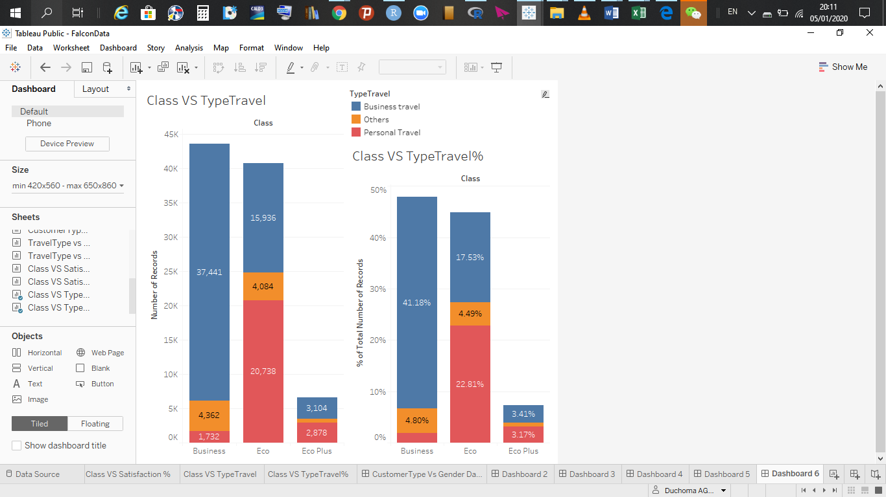

**Observation:**

* Most people who travel for business purposes use Business class. Most people who travel for private reasons use Eco class.
* 41.18% of those who travel for business purposes use business class, 4.80% of people who travel for other reasons use business class and 1.91% of those who travel for personal reasons use business class.
* 17.53% of people who travel for business purposes use Eco class and 22.8% of those who travel for private reasons use Eco.
* 7.3% of customers travel by Eco Plus class.

**Class VS Flight Distance**

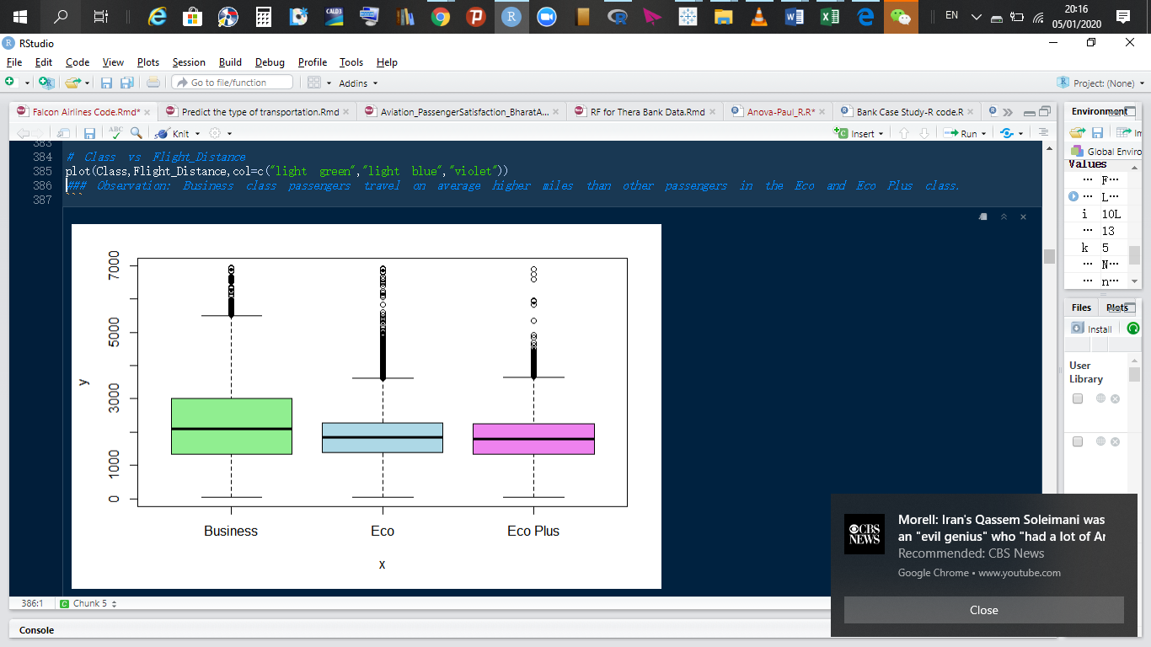

**Observation**

* People who travel for very long number of miles prefer to use business class.

**Age.Bins VS Gender**

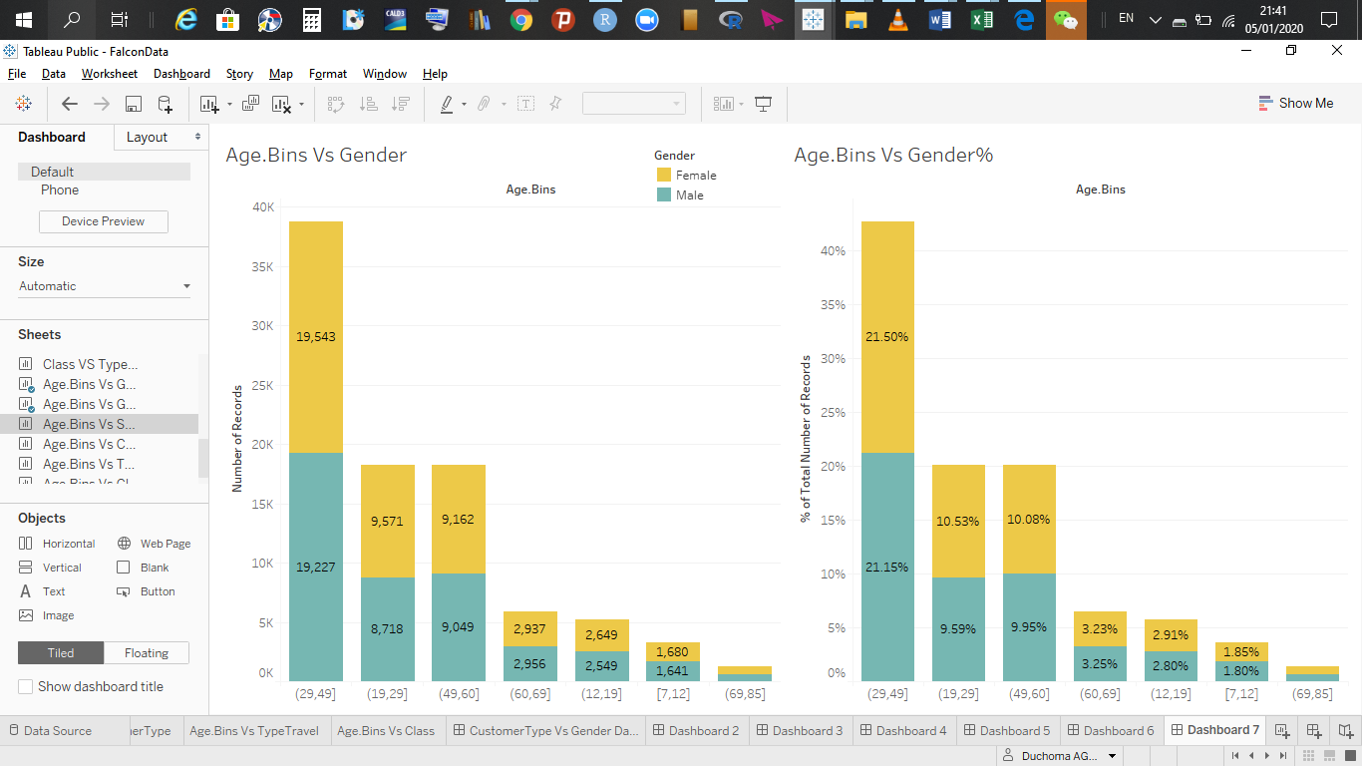

**Observation:**

* As shown above in the male – female partition percentage above, there are more female than male customers and here we see that in each age bucket, there are still more female than male customers.
* The age buckets are arranged in order of the most populous.

**Age.Bins Vs Satisfaction**

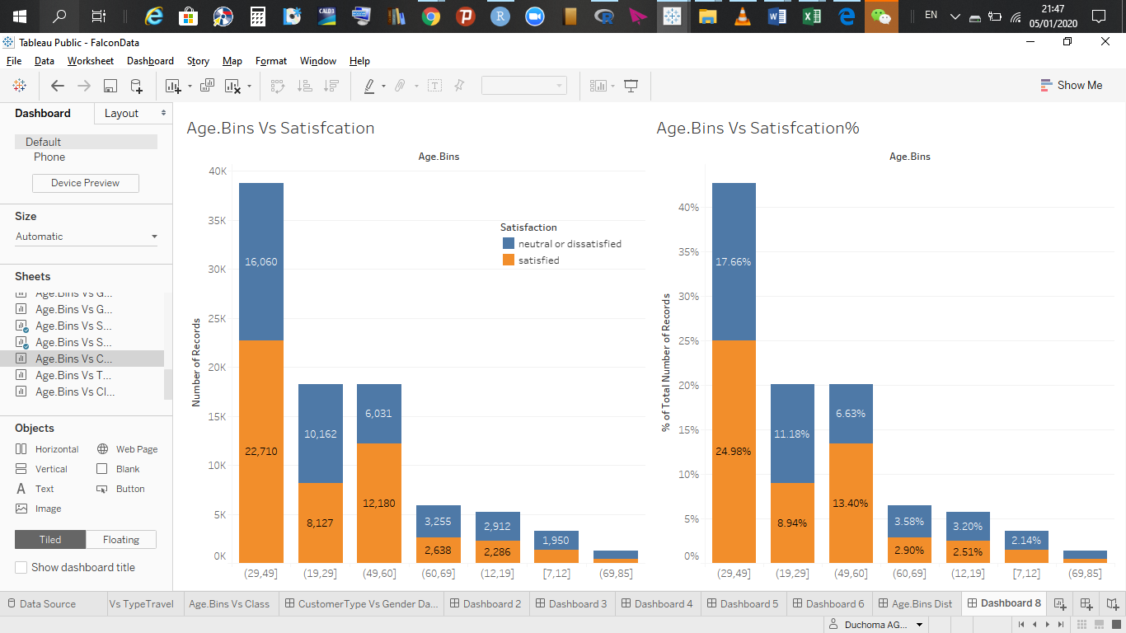

**Observation:**

* (19, 29] are dissatisfied with Falcon-airlines’ in general. Similarly for age group (60, 69], (12, 19], [7, 12] and (69, 85]. The driver for satisfaction for these age groups must be different from other groups. These 5 age groups together make up ……. Of our dataset.
* Age groups (29, 49] and (49, 60] in general are satisfied with Falcon Airlines’ services.

**Age.Bins Vs CustomerType**

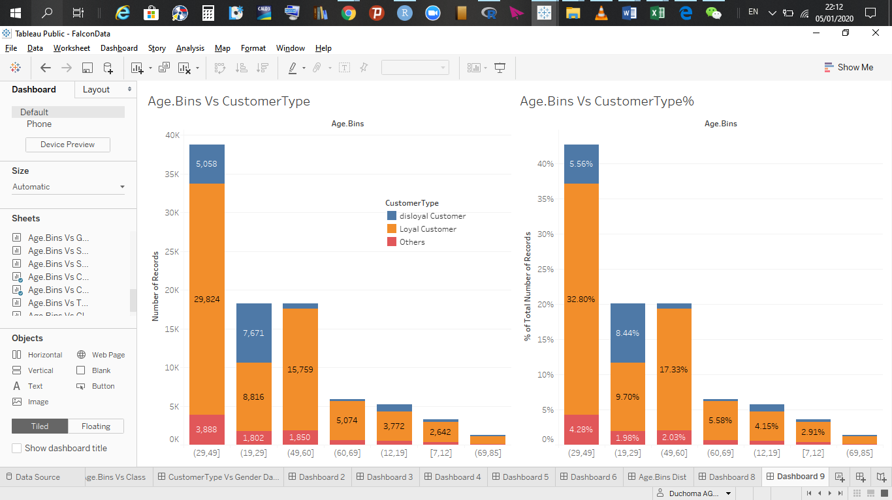

**Observation:**

* Age group (19, 29] has the most disloyal customers and they represent 8.44% of Falcon Airlines customers, followed by customers those who fall in the age group (29, 49].

**Age.Bins Vs TypeTravel**

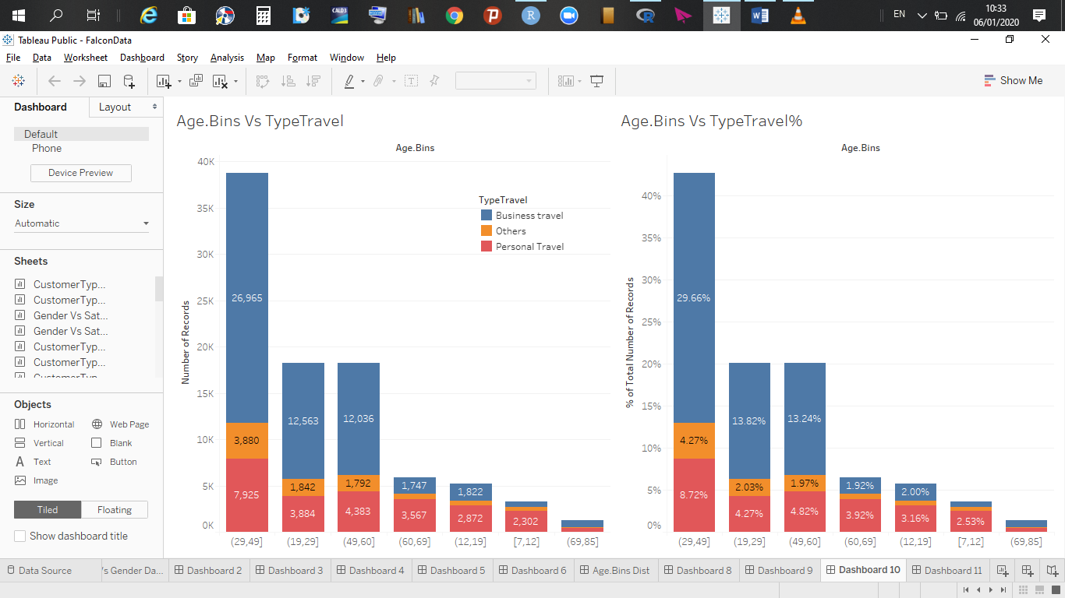

**Observation:**

* The age groups: (60, 69], (12, 19], [7, 12] mostly travel for personal reasons.
* The age groups (29, 49] and (49, 60], (19, 29], and [69, 85] travel more for business purposes and other purposes.

**Age.Bins Vs Class**

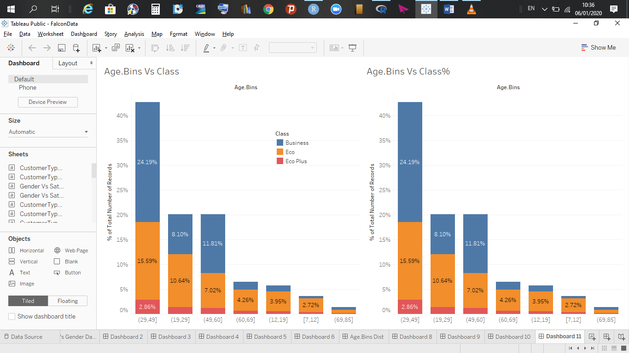

**Observation:**

* All customer age groups take all three classes of travel offered by Falcon Airlines.
* Age groups (29, 49] and (49, 60] prefer business class.
* Age groups (19, 29], (60, 69], (12, 19], [7, 12] and (69, 85] prefer Eco class.

**Age.Bins Vs Flight Distance**

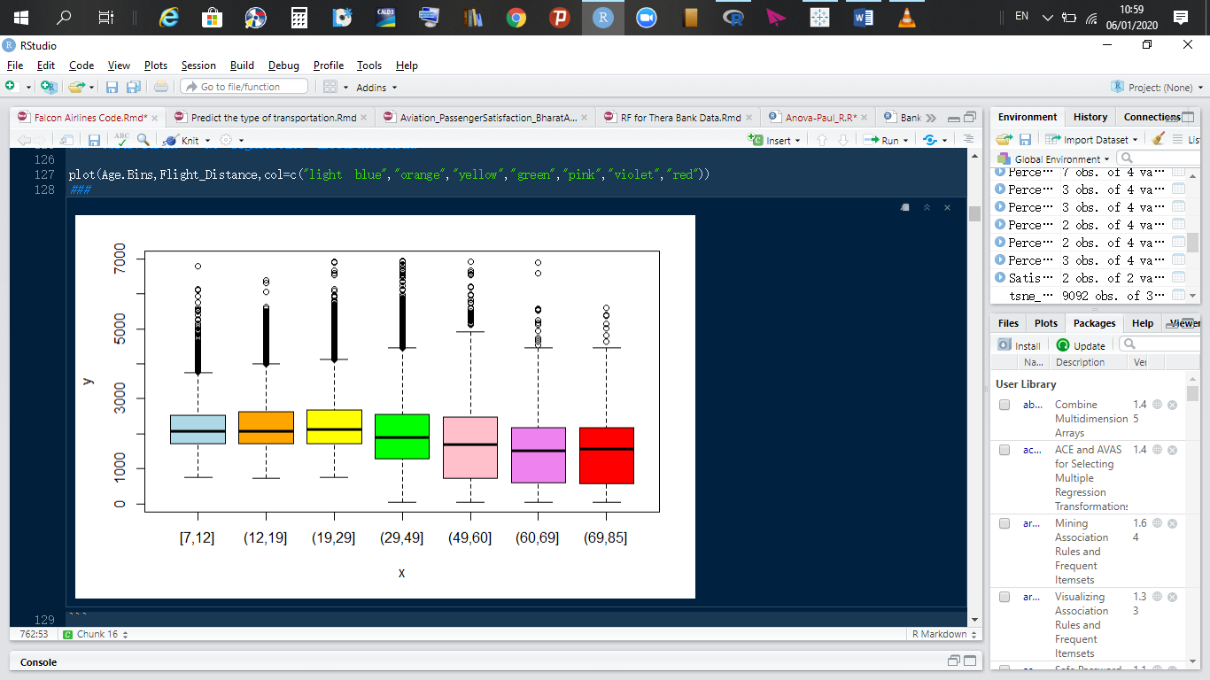

**Observation:**

* The median distance traveled by the age groups [7, 12], (12, 19], (19, 29], and (29, 49] is slightly farther than the distance traveled by the older age groups.

# **3.2.2 Where does Falcon Airline stand with respect to customer groups; segmenting survey data by flight data**

1. **Segmentation by “Gender”**

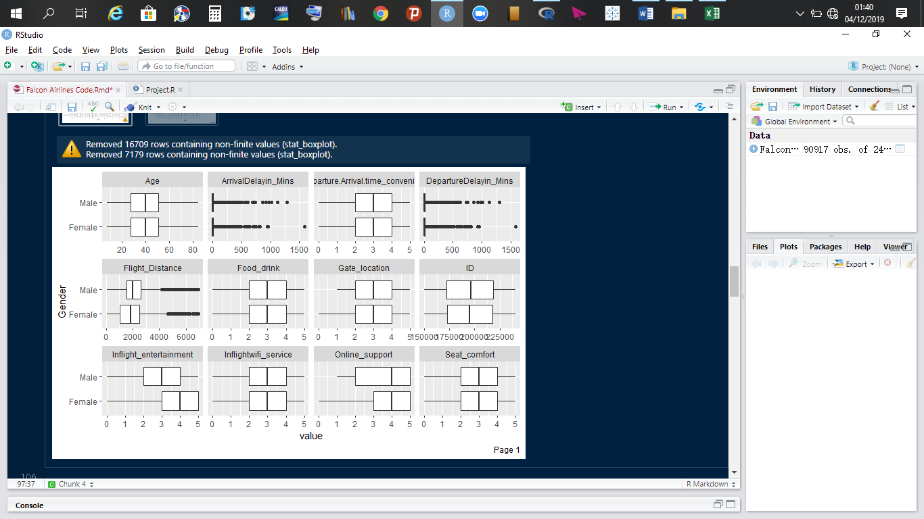

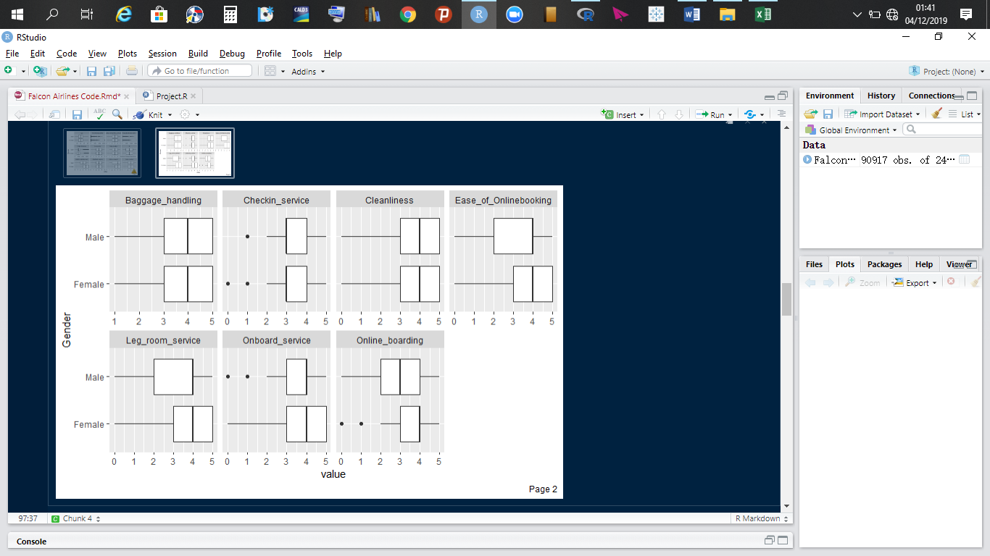

**Observations**

* The median departure and arrival delays is zero minutes, which tells us that the majority of Falcon airlines flights take off and arrive on time.
* Both male and females customers are of the opinion that arrival and departure time is acceptable. However, this should be improved.
* Male customers travel slightly longer distances than female customers.
* Gate location and food and drinks are rated as acceptable by customers.
* Male customers are a little more demanding on inflight entertainment while female customers are of the opinion that inflight entertainment is good.
* Both Male and female customers think inflight Wi-Fi service and seat comfort are acceptable.
* Both rate the company’s online support, baggage handling, cleanliness, ease of online booking, leg room support, on-board service as “good”.
* Checking service was rated as “acceptable”.
* Male customers are a little bit more demanding when it comes to online boarding.

1. **Segmentation by “Customer type”**

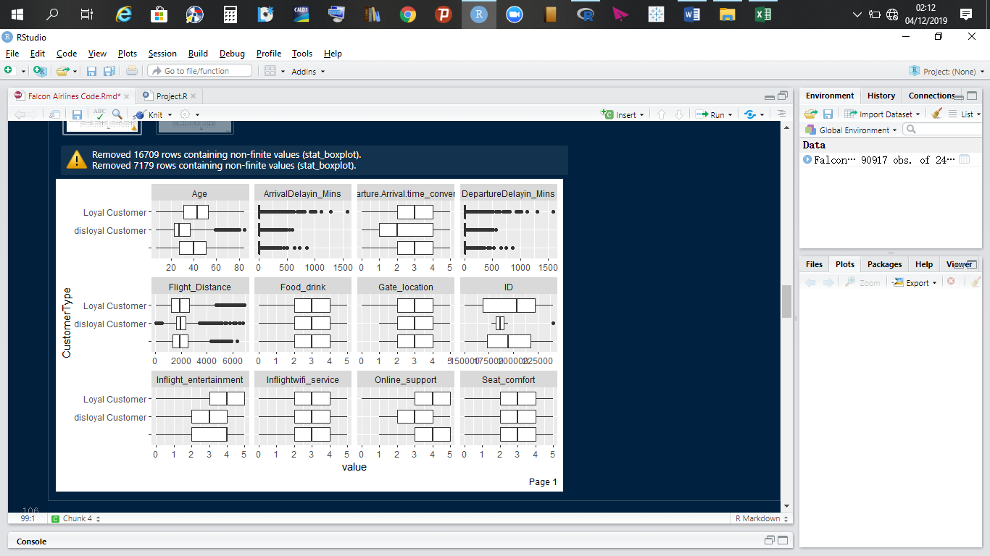

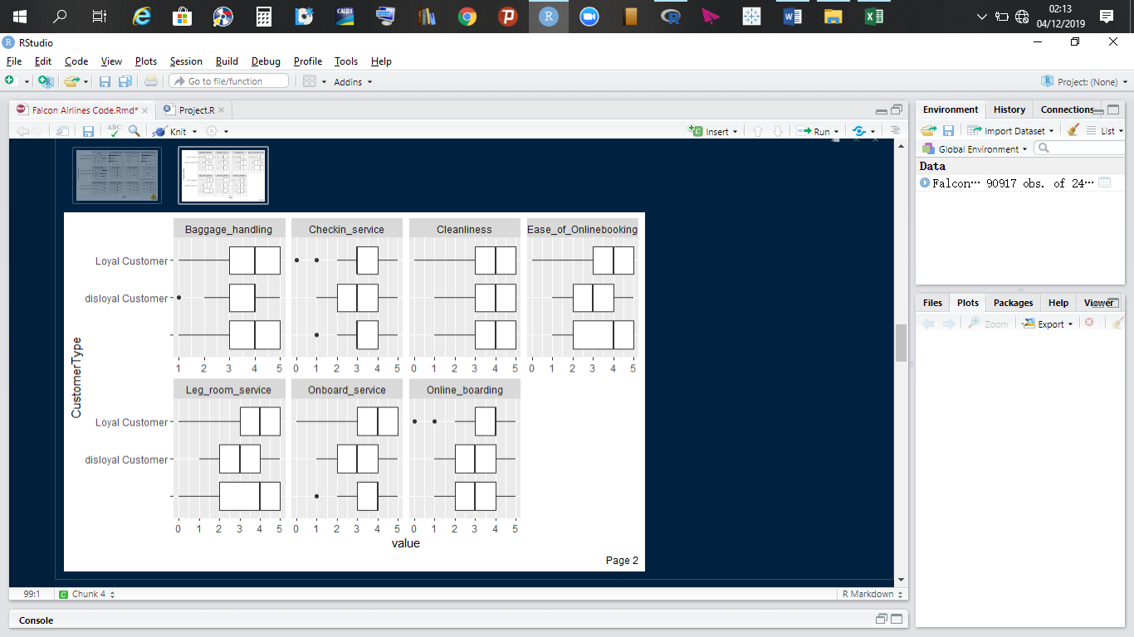

**Observation**

* The median age of loyal customers is in about 42 years, median age of disloyal customers is about 28 years and that of neutral customers is 40.
* Disloyal customers are of the opinion that, departure or arrival time convenience needs improvement.
* All three customer types are of the opinion that food and drink, gate location, inflight Wi-Fi service, and seat comfort are acceptable.
* Younger customers (disloyal customers) are a little more demanding on entertainment and online support.
* Baggage handling was rated as “good” by all customer groups.
* Check-in services was rated “acceptable” by all three categories of customer types.
* Cleanliness was rated as “good” by all customer groups
* Younger customers are a little more demanding when it comes to ease of online booking, leg room service, onboard service and online boarding.

**Recommendations**

* More specified support for younger customers; both company personnel and flight attendants should be more patient with young customers.
* Wi-Fi service aboard aircrafts should be enhanced and improved.
* Seat comforts should be improved.
* If possible, gate location should be shortened, food and drinks should be improved.
* Check-in service should be improved.
* More specified services or directions on the company’s website or mobile application should be provided to help assist customers.
* More tailored services for younger customers.

1. **Segmentation by “Age Bins”**

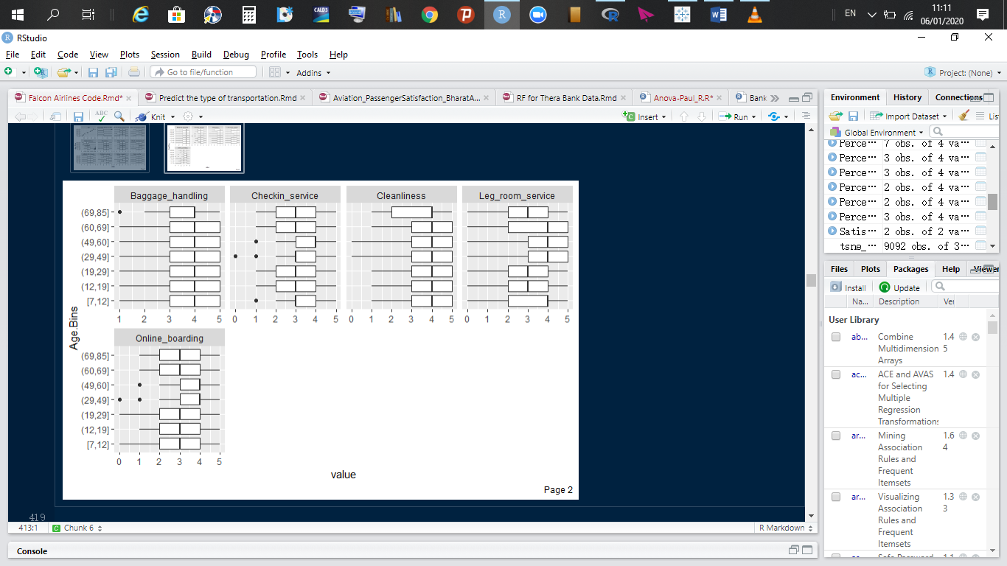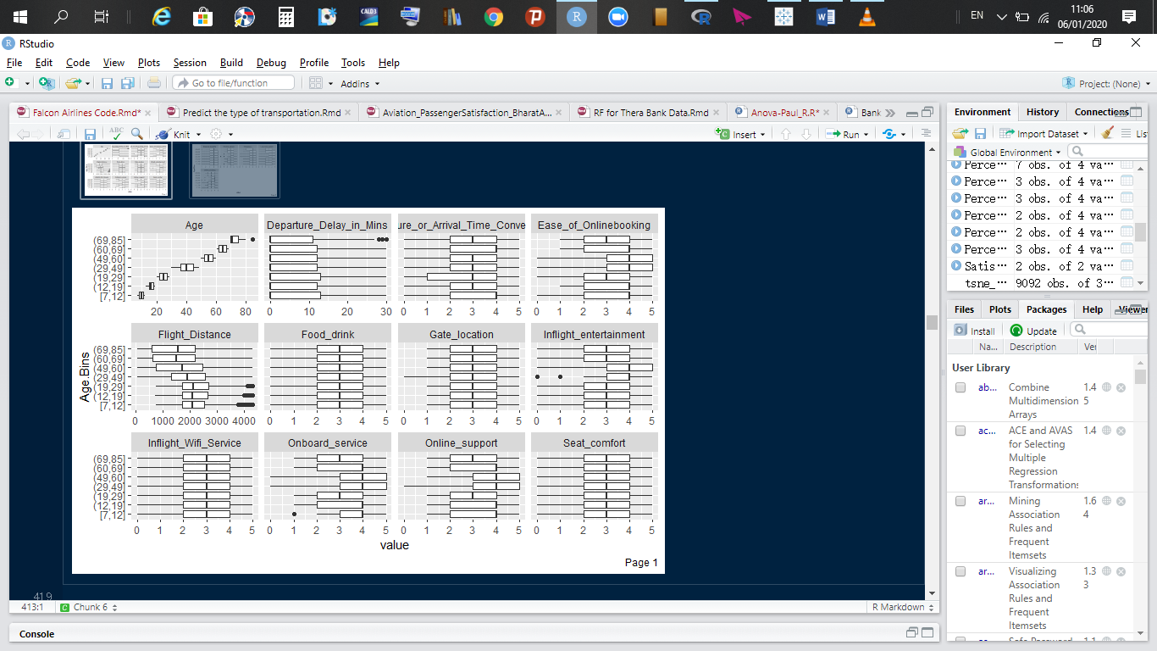

**Observation**

* Apart from [29, 49] and [49, 60] who rated it as good, the remaining age groups rated it as “Acceptable”.
* Younger customers travel slightly more flight distances than other age groups greater than 38 years.
* Inflight entertainment is a critical variable in determining customer satisfaction.
* Age groups (19, 29] and (69, 85] need more assistance with respect to online support.
* Seat comfort, inflight Wi-Fi service, food and drinks, gate location and arrival or departure time convenience were all given a rating of “acceptable” by all customer age segments.
* Baggage handling and cleanliness, was rated as “good” by all customer age groups.

1. **Segmentation by “Class”**

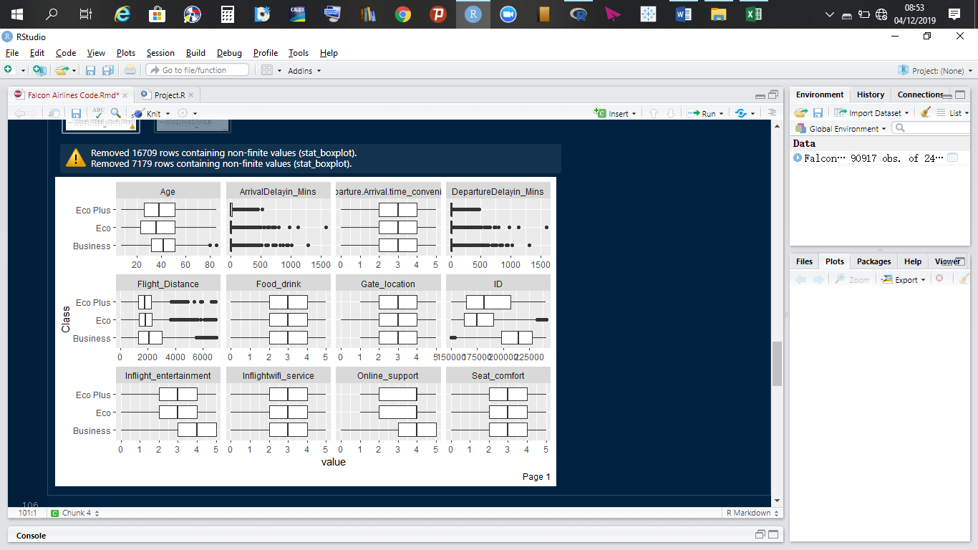

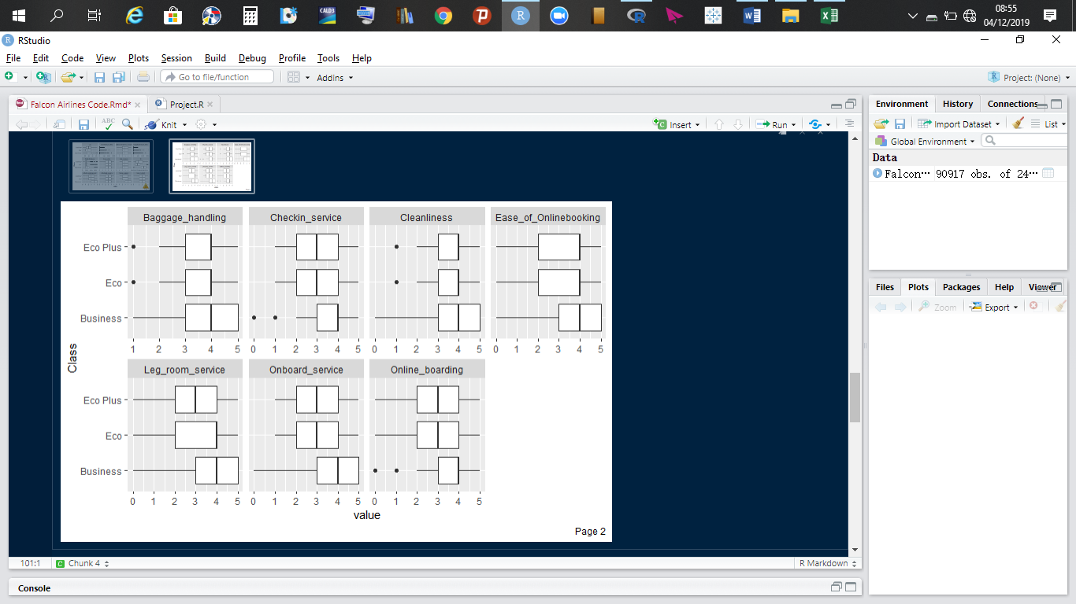

**Observation**

* Compared to all three classes, the median age for Eco class is the lowest, telling us that the median age for Eco class travelers is 38, 40 for Eco Plus and 42 for Business travelers.
* Business class travelers travel slightly longer distances than the other two class passengers.
* Inflight entertainment should tailored to suit Eco Plus and Eco class passengers. Business class passengers rate this service as “good”.
* Eco Plus and Eco class customers are a little more demanding when it comes to online support.
* Departure or arrival time convenience, food and drink, inflight Wi-Fi service, and seat comfort were rated as “acceptable” by all customer classes.
* Baggage handling, ease of online boarding and cleanliness, were rated as “good” by all class passengers.
* Check-in services, leg room services, onboard service and online boarding were all rated as “good” for Business class passengers and rated as “acceptable” Eco Plus and Eco passengers.

1. **Segmentation by “Flight Distance”**

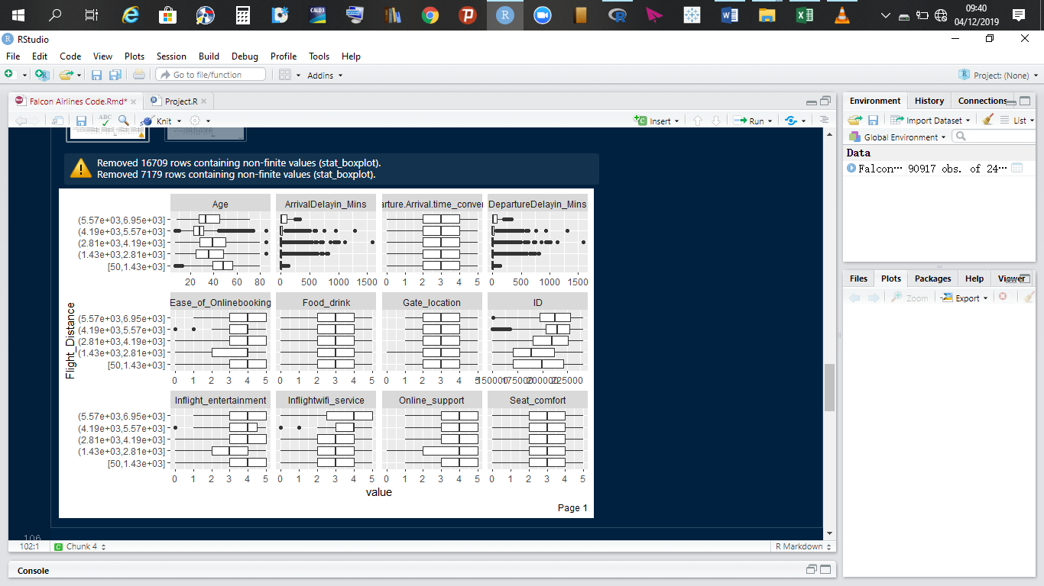

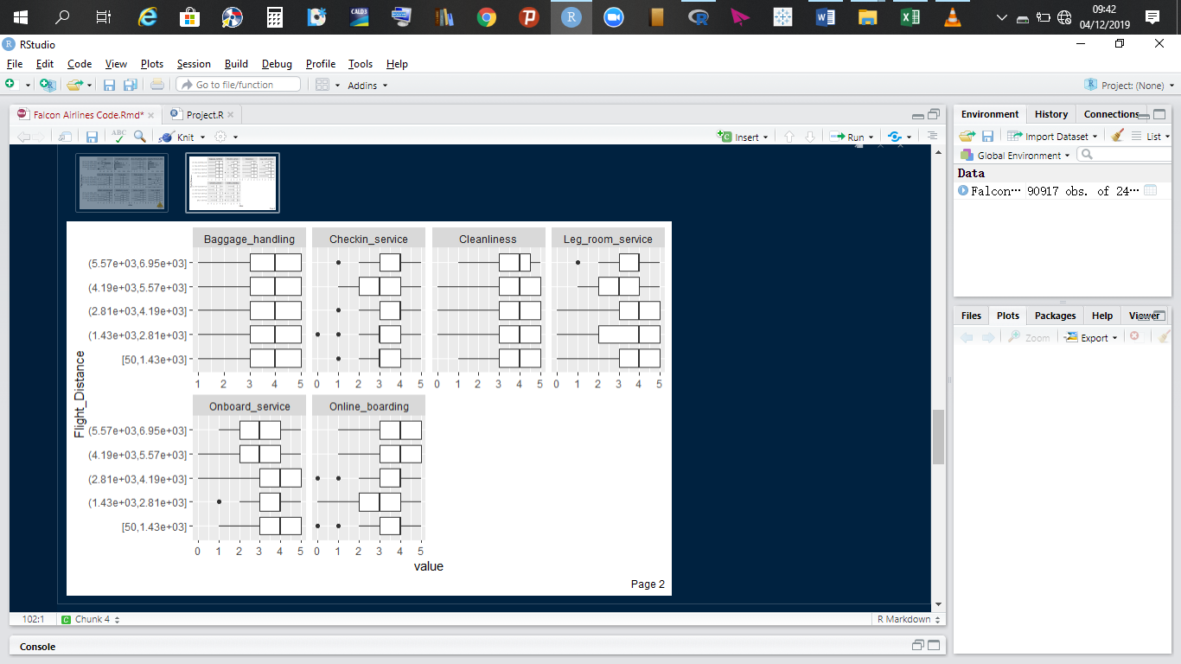

**Observation**

* The median age of customers travelling the most flight distances fall in between 20 to 30.
* Departure or arrival time convenience, food and drink, gate location, seat comfort and online boarding are all rated as “acceptable”.
* Customers in the age median age 28, who travel very long flight distances are a little more demanding with respect to leg room service and onboard boarding.
* Customers travelling distances in the range 4190 to 5570 miles are a little more demanding on leg room services.

1. **Segmentation by “Departure delay in minutes”**

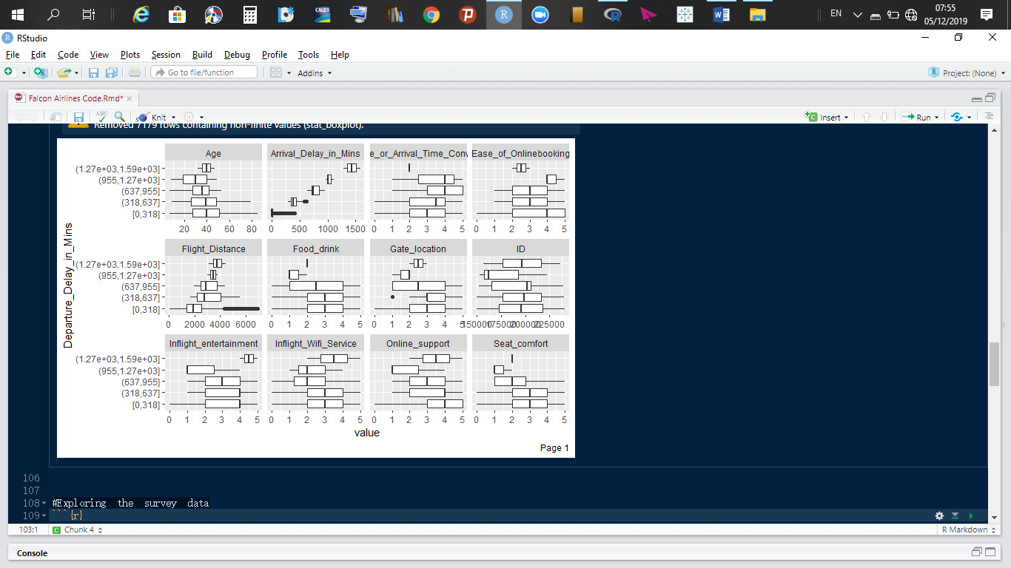

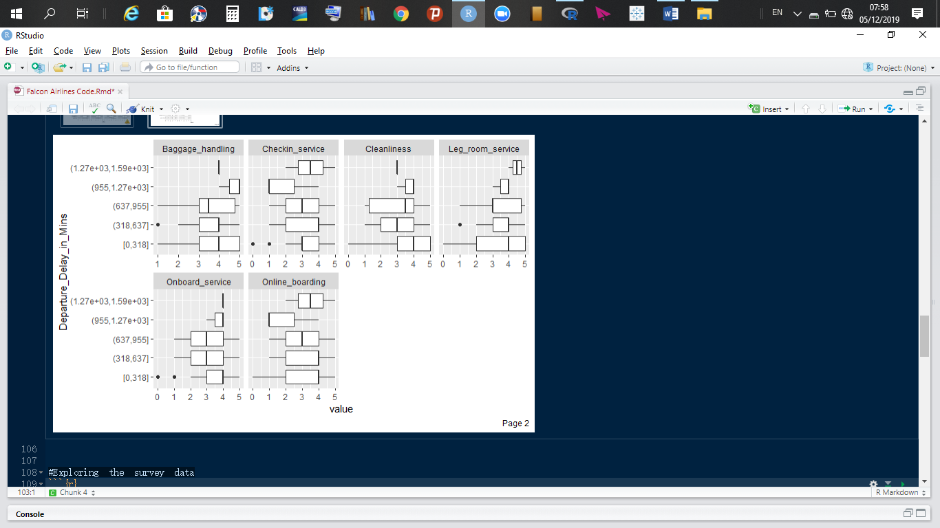

1. **Segmentation by “Arrival delay in minutes”**

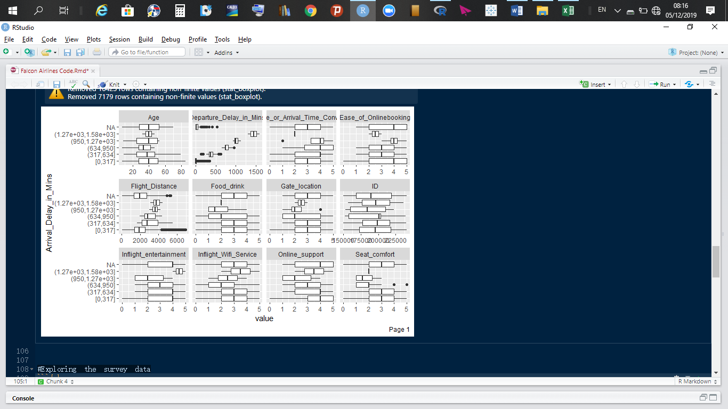

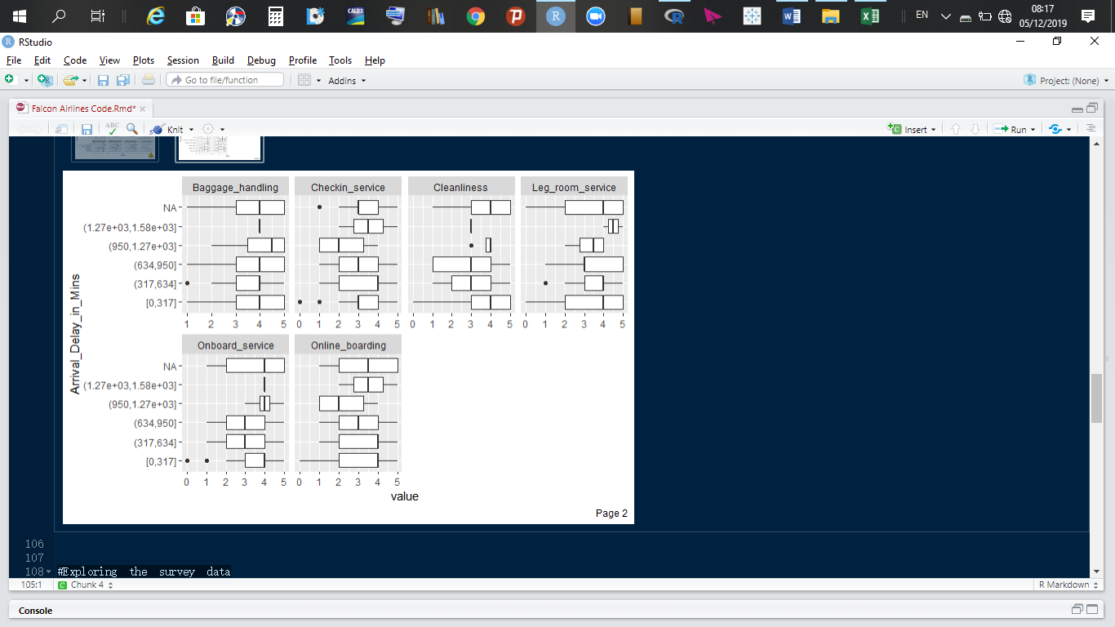

**Observations**

* Delays in departure are most affected by young travelers in the age groups of 30 and 38 years old because such ones travel longer distances than other passengers.
* Food and drinks ratings for such clients reached an all-time low, “needs improvement” and “poor”.
* Similarly, the rating of gate location, seat comfort, inflight Wi-Fi service, inflight entertainment, baggage handling, online boarding, cleanliness, and check in services dropped slightly due to the influence of delays.
* In conclusion, ratings are slightly affected by delays in departures and arrivals.

# **Correlation and histogram plots**

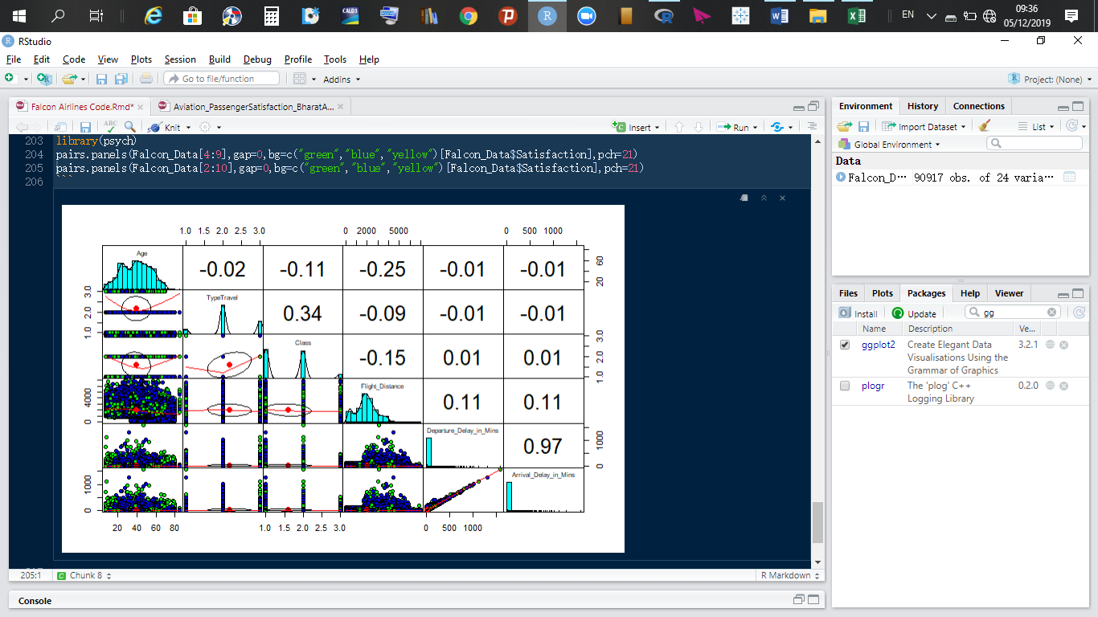

**Observation**

* Delays in departure of a flight reflects in the delays in arrival of flights. Thus, there is a strong positive correlation between these variables.
* The majority of flights take off and arrive on time as shown clearly below:

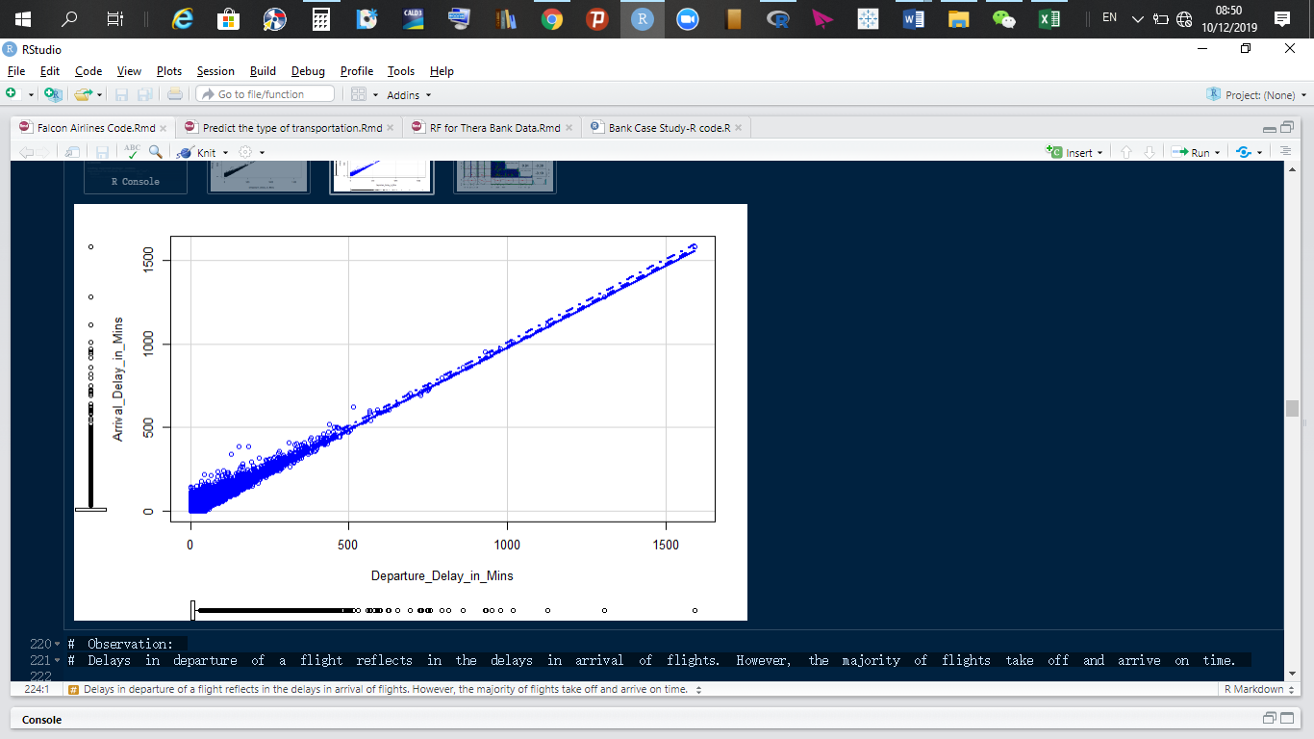

# **Relationship between Categorical data**

* The Chi-squared test is used to investigate the relationship between categorical variable.
* Hypotheses:
  + Ho: The variables are independent.
  + Ha: There is an association between the variables.

Pearson's Chi-squared test

data: Seat_comfort and Leg_room_service

X-squared = 8088, df = 25, p-value < 2.2e-16

Pearson's Chi-squared test

data: CustomerType and TypeTravel

X-squared = 7926.3, df = 4, p-value < 2.2e-16

Pearson's Chi-squared test

data: Satisfaction and Seat_comfort

X-squared = 20235, df = 5, p-value < 2.2e-16

Pearson's Chi-squared test

data: Satisfaction and TypeTravel

X-squared = 1009.2, df = 2, p-value < 2.2e-16

Pearson's Chi-squared test

data: Satisfaction and Class

X-squared = 9011.9, df = 2, p-value < 2.2e-16

Pearson's Chi-squared test

data: Satisfaction and Departure_or_Arrival_Time_Convenience

X-squared = 174.54, df = 5, p-value < 2.2e-16

Pearson's Chi-squared test

data: Satisfaction and Food_drink

X-squared = 5847, df = 5, p-value < 2.2e-16

Pearson's Chi-squared test

data: Satisfaction and Inflight_Wifi_Service

X-squared = 5395.5, df = 5, p-value < 2.2e-16

Chi-squared approximation may be incorrect

Pearson's Chi-squared test

data: Satisfaction and Gate_location

X-squared = 1929.8, df = 5, p-value < 2.2e-16

Chi-squared approximation may be incorrect

Pearson's Chi-squared test

data: Cleanliness and Food_drink

X-squared = 474.76, df = 25, p-value < 2.2e-16

Chi-squared approximation may be incorrect

Pearson's Chi-squared test

data: Satisfaction and Online_support

X-squared = 16940, df = 5, p-value < 2.2e-16

Chi-squared approximation may be incorrect

Pearson's Chi-squared test

data: Satisfaction and Online_boarding

X-squared = 11019, df = 5, p-value < 2.2e-16

Chi-squared approximation may be incorrect

Pearson's Chi-squared test

data: Online_support and Ease_of_Onlinebooking

X-squared = 103955, df = 25, p-value < 2.2e-16

Chi-squared approximation may be incorrect

Pearson's Chi-squared test

data: Satisfaction and Onboard_service

X-squared = 10870, df = 5, p-value < 2.2e-16

Chi-squared approximation may be incorrect

Pearson's Chi-squared test

data: Satisfaction and Checkin_service

X-squared = 7198.2, df = 5, p-value < 2.2e-16

Chi-squared approximation may be incorrect

Pearson's Chi-squared test

data: Satisfaction and Cleanliness

X-squared = 8452.8, df = 5, p-value < 2.2e-16

Chi-squared approximation may be incorrect

Pearson's Chi-squared test

data: Inflight_Wifi_Service and Inflight_entertainment

X-squared = 13325, df = 25, p-value < 2.2e-16

Chi-squared approximation may be incorrect

Pearson's Chi-squared test

data: Gate_location and Departure_or_Arrival_Time_Convenience

X-squared = 112245, df = 25, p-value < 2.2e-16

Chi-squared approximation may be incorrect

Pearson's Chi-squared test

data: Onboard_service and Checkin_service

X-squared = 6273.9, df = 25, p-value < 2.2e-16

Chi-squared approximation may be incorrect

Pearson's Chi-squared test

data: Online_support and Online_boarding

X-squared = 123728, df = 25, p-value < 2.2e-16

Chi-squared approximation may be incorrect

Pearson's Chi-squared test

data: Online_boarding and Ease_of_Onlinebooking

X-squared = 184463, df = 25, p-value < 2.2e-16

Given alpha = 0.05 as our level of significance, and given the p-values in the above results, which are all less than 0.05, we overwhelmingly fail to accept the null hypothesis that the variables are independent and thus, conclude that, there is an association or a relationship with the variables tested.

The survey data parameters all have an association or affect the value customers derive from Falcon Airlines Company.

# **Relationship between numerical and categorical variables**

We performed a linear regression

Call:

lm(formula = Satisfaction ~ ., data = Falcon_Data)

Residuals:

Min 1Q Median 3Q Max

-1.17491 -0.24942 0.00544 0.22593 1.53766

Coefficients:

Estimate Std. Error t value Pr(>|t|)

(Intercept) 7.324e-01 1.070e-02 68.432 < 2e-16 ***

GenderMale -1.345e-01 2.454e-03 -54.782 < 2e-16 ***

CustomerTypedisloyal Customer -2.255e-01 5.084e-03 -44.349 < 2e-16 ***

CustomerTypeLoyal Customer 5.487e-02 4.061e-03 13.513 < 2e-16 ***

Age -9.869e-04 8.672e-05 -11.379 < 2e-16 ***

TypeTravelBusiness travel 2.253e-02 4.151e-03 5.427 5.74e-08 ***

TypeTravelPersonal Travel -5.995e-02 4.707e-03 -12.735 < 2e-16 ***

ClassEco -1.287e-01 3.251e-03 -39.573 < 2e-16 ***

ClassEco Plus -1.297e-01 5.091e-03 -25.468 < 2e-16 ***

Flight_Distance -1.633e-05 1.284e-06 -12.720 < 2e-16 ***

Departure_Delay_in_Mins -2.273e-03 1.068e-04 -21.282 < 2e-16 ***

Seat_comfort 5.009e-02 1.348e-03 37.150 < 2e-16 ***

Departure_or_Arrival_Time_Convenience -2.932e-02 1.061e-03 -27.638 < 2e-16 ***

Food_drink -3.591e-02 1.379e-03 -26.038 < 2e-16 ***

Gate_location 1.497e-02 1.201e-03 12.463 < 2e-16 ***

Inflight_Wifi_Service -9.728e-03 1.290e-03 -7.539 4.78e-14 ***

Inflight_entertainment 1.062e-01 1.231e-03 86.263 < 2e-16 ***

Online_support 1.399e-02 1.401e-03 9.979 < 2e-16 ***

Ease_of_Onlinebooking 4.008e-02 1.792e-03 22.362 < 2e-16 ***

Onboard_service 4.153e-02 1.256e-03 33.054 < 2e-16 ***

Leg_room_service 3.105e-02 1.089e-03 28.506 < 2e-16 ***

Baggage_handling 1.150e-02 1.437e-03 8.007 1.19e-15 ***

Checkin_service 3.907e-02 1.045e-03 37.385 < 2e-16 ***

Cleanliness 8.635e-03 1.488e-03 5.801 6.60e-09 ***

Online_boarding 1.934e-02 1.511e-03 12.797 < 2e-16 ***

---

Signif. codes: 0 ‘***’ 0.001 ‘**’ 0.01 ‘*’ 0.05 ‘.’ 0.1 ‘ ’ 1

Residual standard error: 0.3595 on 90892 degrees of freedom

Multiple R-squared: 0.4786, Adjusted R-squared: 0.4785

F-statistic: 3477 on 24 and 90892 DF, p-value: < 2.2e-16

# **Treatment of missing observations from data**

Treatment of missing values was done using "mice" library.

**Procedures**

1. We found the percentage of missing data in each variables.

* Arrival_Delay_in_Mins has 0.31% of missing data.
* Food_drink contains 8.99% of missing data.
* Onboard_service contains 7.89% of missing data.
* Departure_or_Arrival_Time_Convenience contains 9.06% of missing data.

1. Missing data pattern of our dataset.

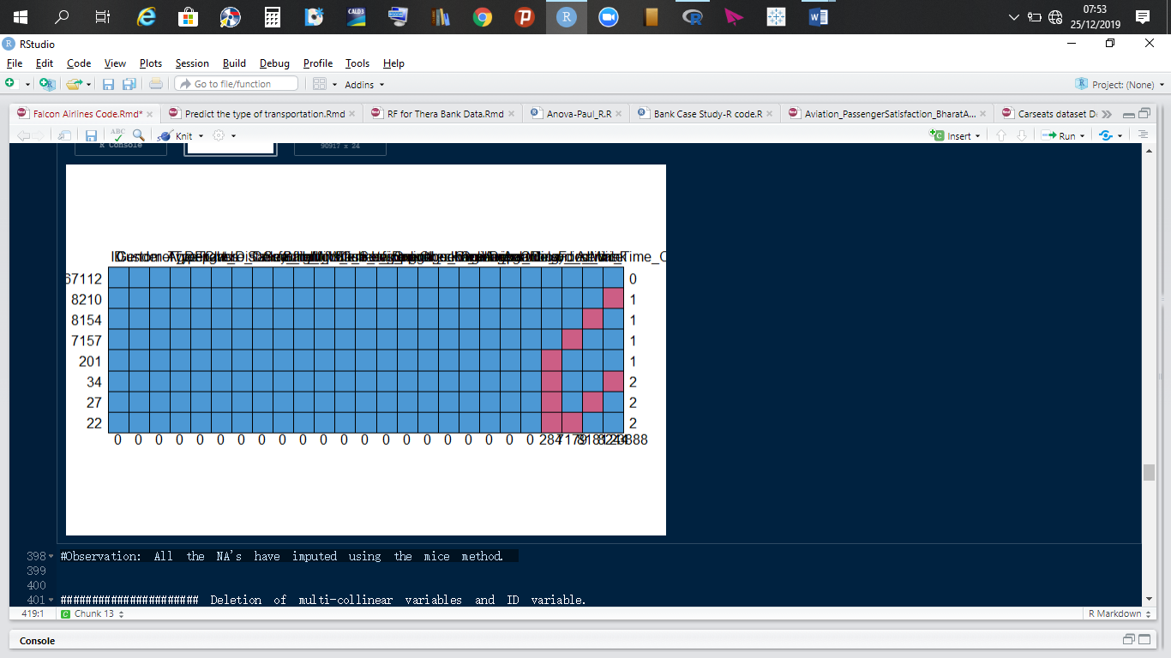

The method for dealing with imputing numeric values is pmm=predictive mean matching. The method used for imputing categorical variables is polyreg=multinomial logistic regression"

Our data was imputed correctly for missing observations.

# **Train and test splits**

* Our dataset was split into a 70-30 percentage ratio. This splitting criteria was for the train and test datasets respectively.
* We set the seed to make sure the splitting process remains the same if algorithm is run at a later date, since this process is a random one.
* Uniformity after split of data was achieved. “1” and “2” stand for unsatisfied or neutral and satisfied respectively. This partition follows the same pattern in the original dataset.

1 2

41156 49761

1 2

0.4526766 0.5473234

# **Classification and regression tree (CART)**

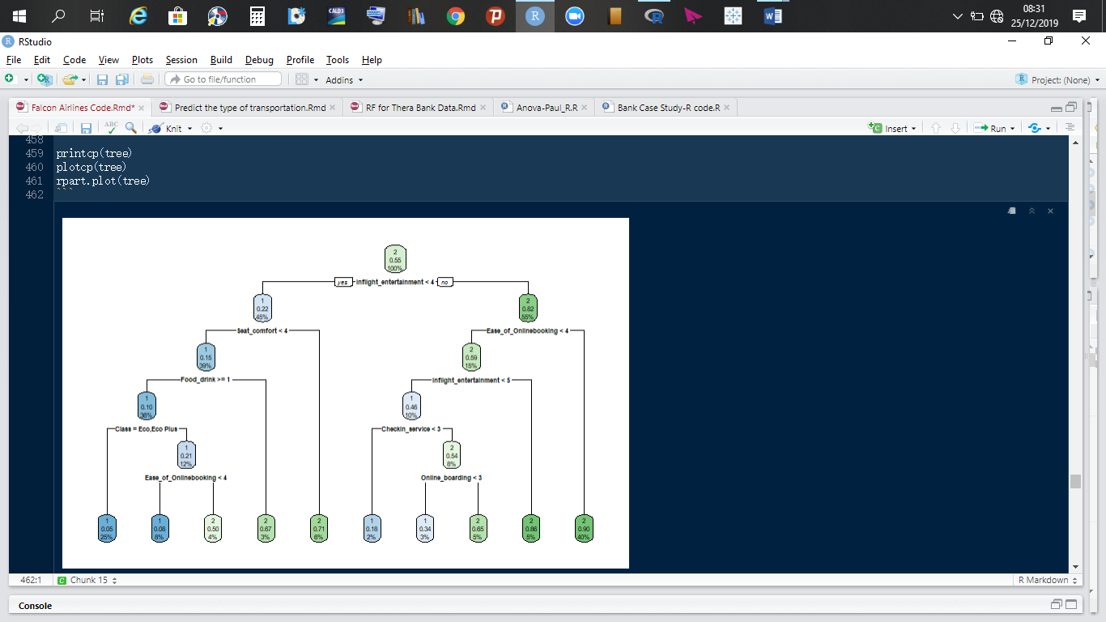

**Observation**

* In CART model, we have only binary splits at each node. The splits happen based on our pre-pruning and post-pruning steps. The printed tree is quite huge. The tree divided our customers into 10 buckets. We will explain the tree in details for the pruned CART.
* The "cp" (cost complexity) parameter of the CART tree cannot be tuned further at this stage since at "cp"=0.0001652, the “xerror” is lowest.

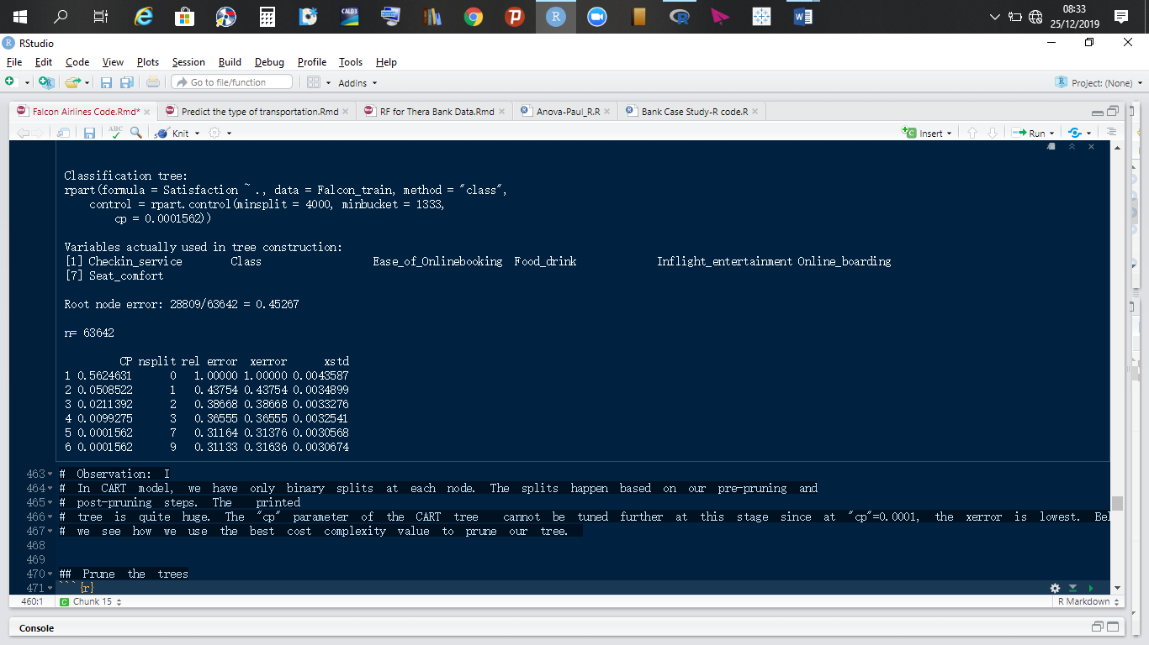

Below, we see how we use the best cost complexity value to prune our tree. We will use this tree to illustrate

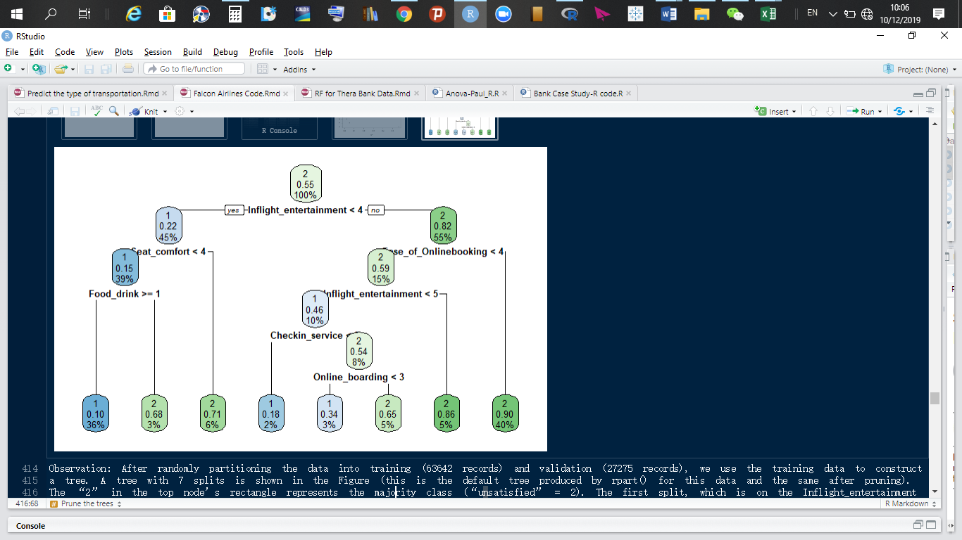

**Observation:**

* “2” on the top node stands for satisfied and “1” stands for dissatisfied.
* We started with a 55% and 45.3% of customers who are overall satisfied and unsatisfied with Falcon airlines services. The Gini has helped in getting a better percentage of people who are likely to be satisfied with Falcon airlines services.
* Our CART or any classification algorithm will give us a differentiation in the inventory, that is, while the average satisfaction of customers is 55%, the final nodes contain different percentages of satisfaction. Differentiation of inventory translates into the key factors responsible for customer satisfaction.

**Interpretation of decision tree**

The overall satisfaction of customers is 55%. Our decision tree is telling us that:

1. Those who rate **in-flight entertainment < 4** have an overall satisfaction of have an average satisfaction of 22% while those who rate it greater than 4 have an average satisfaction of 82% and 55% of customers fall in this bucket. Thus, inflight entertainment is the most important driver for customer satisfaction.

**Recommendation:**

* Improve entertainment for all classes of travel. Prior analysis revealed o us that younger customers and those between [70, 85] are very demanding on entertainment. Falcon Airlines should prepare various entertainment packages for all age groups.
* Falcon Airlines can partner with the entertainment industry to share some useful intelligence on what the various age demographics care about.

1. Customers who rate **in-flight entertainment > 4** and rate and also rate **Ease of online booking** > 4 have an overall satisfaction of 90% compared to those who rate **Ease of online booking** < 4. Thus, **ease of online booking** is the second most important driver of customer satisfaction.

**Recommendation:**

* Falcon Airlines should make online booking such that it is perceived as easy by the customers.
* Falcon Airlines should make the online booking technology user friendly.

1. If people are rating **in-flight entertainment** as bad and are also rating **Seat comfort** as bad, then, their satisfaction rate is 15% but those rating seat comfort as good have a satisfaction rate of 71%. Thus, **seat comfort** is the third most important driver of customer satisfaction.

**Recommendation:**

* Seat comfort should be improved for economic and economic pro class since prior analysis showed they are not happy with the seat comfort, especially among [20, 29] and [70, 85] age groups.
* Seat comfort should be improved on Falcon Airlines’ aircrafts.

1. Customers’ rating **online boarding** as good have an overall satisfaction of 65% while those rating it as bad have an overall satisfaction rate of 34%.

**Recommendation:**

* The technology used by Falcon Airlines should be user friendly and also online support should be very effective.

1. Finally, customers not happy with inflight entertainment, seat comfort and food and drinks have an overall satisfaction rate of 10% while those not happy with inflight entertainment, seat comfort but are happy with **food and drinks** have an overall satisfaction rate of 68%.

Thus, the our most significant variables as printed by or tree which are responsible for customer satisfaction is Inflight_entertainment, Ease of online booking, seat comfort, Food and drinks and online boarding.

# **Variables of importance printed by the software**

The determination of whether or not a customer will be satisfied with Falcon airlines services is determined by the following variables as listed in order of importance.

|  |  |
| --- | --- |
| **Variables** | **ptree.variable.importance** |
| Inflight_entertainment | 12,744.4756440 |
| Seat_comfort | 6,338.7701561 |
| Online_support | 5,577.1183384 |
| Ease_of_Onlinebooking | 4,683.6480456 |
| Online_boarding | 3,770.5658036 |
| Food_drink | 3,590.8491927 |
| Cleanliness | 432.7667146 |
| Baggage_handling | 349.5949020 |
| Checkin_service | 308.8187098 |
| Onboard_service | 282.5112648 |
| Inflight_Wifi_Service | 136.0618373 |
| Leg_room_service | 47.9076719 |
| CustomerType | 32.9082184 |
| Age | 0.8010861 |
| Flight_Distance | 0.2259791 |

Thus, in order for Falcon Airlines to increase satisfaction for its customers, it needs to allocate resources in improving the various services in its company. For the three different classes, it should prioritize Business and Eco class, since significant number of customers use it all the time.

**Alternative method to getting variables of importance**

We could have used random forest algorithm to arrive at the critical variables responsible for a clients’ satisfaction or dissatisfaction. Since the random forest focuses on accuracy, the MeanDecreaseGini is what we will consider when extracting the variables of importance in determining whether or not a client will be satisfied.

# **Model performance measures**

**Train data performance measures**

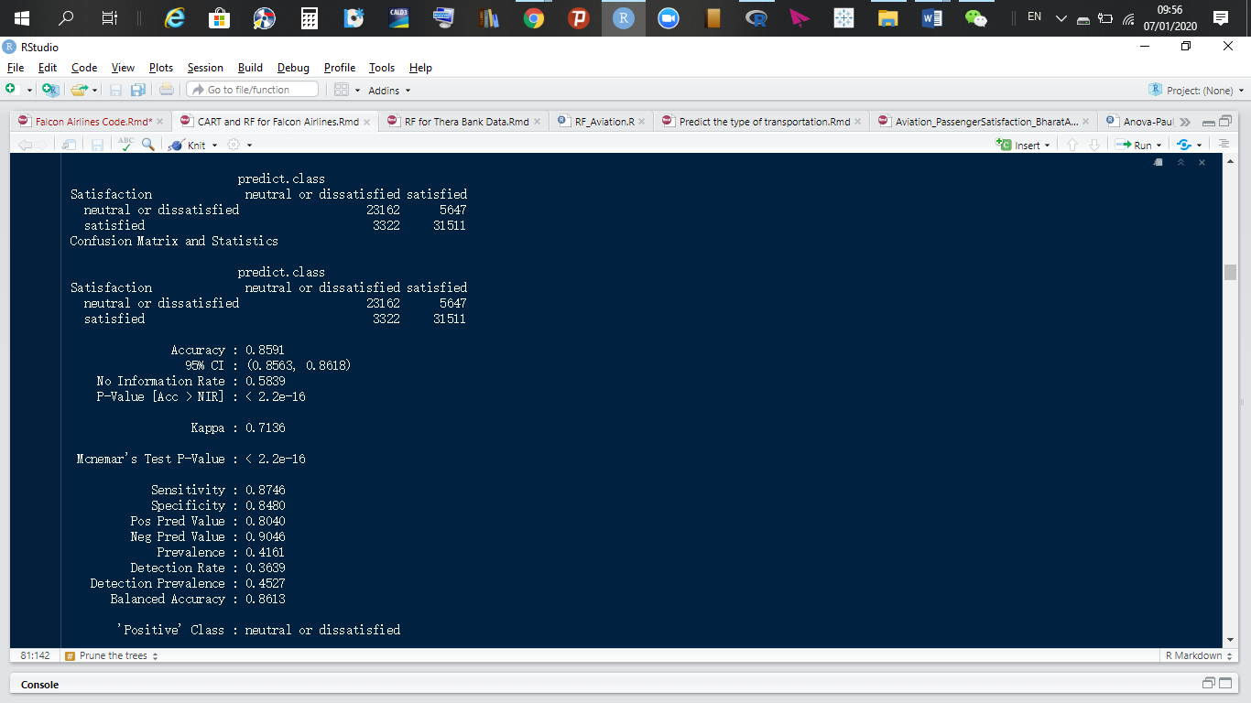

Our tree predicted that 23,162 customers will be dissatisfied and it turned out to match the actual. It also predicted 31,511 customers will be satisfied, which turned out to be true. Leading to an accuracy rate of 85.91%.

Our sensitivity rate is 87.46%; our model predicted 31,511 people will be satisfied after flying aboard Falcon Airlines and it was 87.46% correct.

Finally, our specificity rate is 84.80%, meaning the number of people predicted to be satisfied post flight but turned out they weren't was 5647 and those predicted to have been dissatisfied but turned out they were actually satisfied was 3322. These numbers are great. To validate them, we will run our model on our test data.

**Test data performance measures**

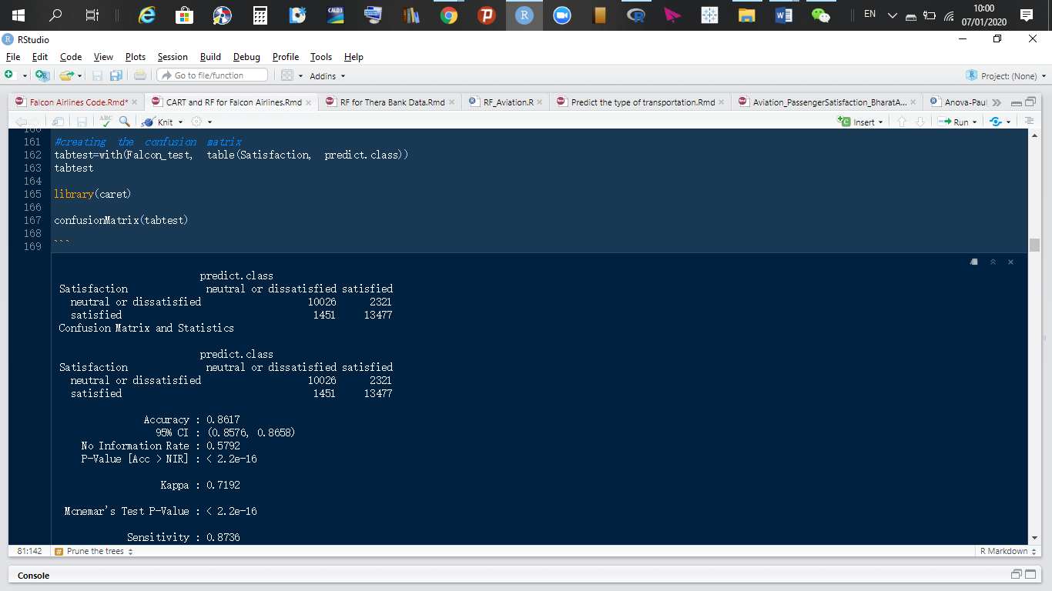

Our tree predicted that 10,026 customers will be dissatisfied and it turned out to match the actual. It also predicted 13,477 customers will be satisfied, which turned out to be true. Leading to an accuracy rate of 86.17%.

Our sensitivity rate is 87.36%; our model predicted 13,477 people will be satisfied after flying aboard Falcon Airlines and it was 87.36% correct.

Finally, our specificity rate is 85.31%, meaning the number of people predicted to be satisfied post flight but turned out they weren't was 2321 and those predicted to have been dissatisfied but turned out they were actually satisfied was 1451. Our random forest predicted accurately.

**Kolmogrorov-Smirnov Tests and Area under the curve**

**Train data:** The KS value is 70.86% and the area under the curve is 88.93%. Thus, high accuracy.

**Test data:** The KS value is 71.48% and the area under the curve is 89.06%. Thus, high accuracy.

|  |  |  |  |
| --- | --- | --- | --- |
| **Performance Measures for CART Model** | | | |
| **CART** | **Accuracy** | **Sensitivity** | **Specificity** |
| **Train data** | 85.91% | 87.46% | 84.80% |
| **Test data** | 86.17% | 87.36% | 85.31% |
| **Overfitting** | NO | NO | NO |
|  |  |  |  |
| **CART** | **KS** | **AUC** |  |
| **Train data** | 70.86% | 88.93% |  |
| **Test data** | 71.48% | 89.06% |  |

Our CART performed very well.

# **Customer Segmentation**

Knowing which customers to target first and which to target next will depend on how we segment our customers. Segmentation will help us know how to best serve our clients. We generated a stratified sample of 9092 observations, representing 10% of our data. A stratified random sample will help us create a statistically significant sample from a huge dataset. A stratified sample keeps the same statistical information of the population.

The variables of importance were gotten for the entire data. From our elementary data analysis, we observed discrepancies in male and female customers’ ratings of the survey, we also observed discrepancies in their satisfaction rates. Also, the splitting of customer ages into groups helped shine light on customer behavior with respect to some aspects of Falcon Airlines’ services. Obviously, the drivers of satisfaction for males, females and the different age groups are different. For this reason, we used 10% of our data and ran a clustering algorithm with distance matrix choice being Gower. K-means and hierarchical clustering techniques couldn’t be used because the algorithms don’t take into consideration categorical data types, but PAM does. We clustered our data into five segments. These segments were stored as separate datasets and then were inserted into our decision tree algorithm to find the variables of importance or drivers of satisfaction for the various segments.

# **Clustering algorithm: partitioning around medoids (pam)**

The Gower distance fits well with the k-medoids algorithm. k-medoid is a classical partitioning technique of clustering that clusters the data set of n objects into k clusters known a priori.

We use the silhouette coefficient to choose the number of clusters. The silhouette coefficient contrasts the average distance to elements in the same cluster with the average distance to elements in other clusters. Objects with a high silhouette value are considered well clustered, objects with a low value may be outliers. This index works well with k-medoids clustering, and is also used to determine the optimal number of clusters.

We Visualized our clusters in a lower dimensional space, with t-SNE, using Rtsne() function in R. t-Distributed Stochastic Neighbour Embedding (t-SNE) is a technique for dimensionality reduction that is particularly well suited for the visualization of high-dimensional datasets.

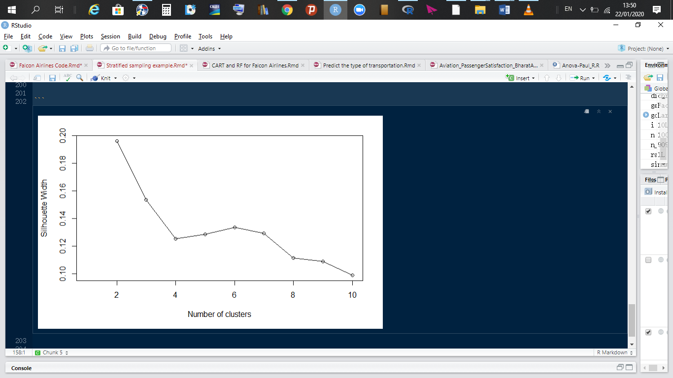

Interpretation from the silhouette visual showed that 2 is the most appropriate number of clusters because it has the highest Silhouette width distance. Given that we have categories of customer type, class, type travel and gender, we resulted to choosing 8 clusters. The summary of the clusters can be seen in the diagram below. In the end, we ended with 7 clusters since clusters 6 and 8 have similar characteristics.

|  |  |  |  |  |  |  |
| --- | --- | --- | --- | --- | --- | --- |
| Clusters | Gender | Customer Type | Type Travel | Class | Satisfaction | Age Bins |
| 1 | Female | Loyal customers | Business travel | Business | Satisfied | (49,60] |
| 2 | Female | Loyal customers | Business travel | Business | Dissatisfied | (29,49] |
| 3 | Female | Disloyal | Business travel | Eco | Dissatisfied | (19,29] |
| 4 | Female | Loyal | Business travel | Business | Satisfied | (29,49] |
| 5 | Male | Loyal customers | Business travel | Business | Satisfied | (29,49] |
| 6 | Male | Loyal customers | Personal travel | Eco | Dissatisfied | (29,49] |
| 7 | Female | Loyal customers | Personal travel | Eco | Satisfied | (29,49] |
| 8 | Male | Loyal customers | Personal travel | Eco | Dissatisfied | (29,49] |

**Observation:**

* The majority of customers from cluster 1 are loyal female customers who travel for business reasons and fly using business class and they are mostly satisfied. The majority of them are in the age group of (49, 60].
* The majority of customers from cluster 2 are loyal female customers who travel for business reasons and fly using business class and they are mostly dissatisfied. The majority of them are in the age group of (29, 49].
* The majority of customers from cluster 3 are disloyal female customers who travel for business reasons and fly using Eco class and they are mostly dissatisfied. The majority of them are in the age group of (19, 29].
* The majority of customers from cluster 4 are loyal female customers who travel for business reasons and fly using business class and they are mostly satisfied. The majority of them are in the age group of (29, 49].
* The majority of customers from cluster 5 are loyal male customers who travel for business reasons and fly using business class and they are mostly satisfied. The majority of them are in the age group of (29, 49].
* The majority of customers from cluster 6 are loyal male customers who travel for personal reasons and fly using Eco class and they are mostly dissatisfied. The majority of them are in the age group of (29, 49].
* The majority of customers from cluster 7 are loyal female customers who travel for personal reasons and fly using Eco class and they are mostly satisfied. The majority of them are in the age group of (29, 49].
* The majority of customers from cluster 8 are loyal male customers who travel for personal reasons and fly using Eco class and they are mostly dissatisfied. The majority of them are in the age group of (29, 49].

# **Visualization in a lower dimensional Space**

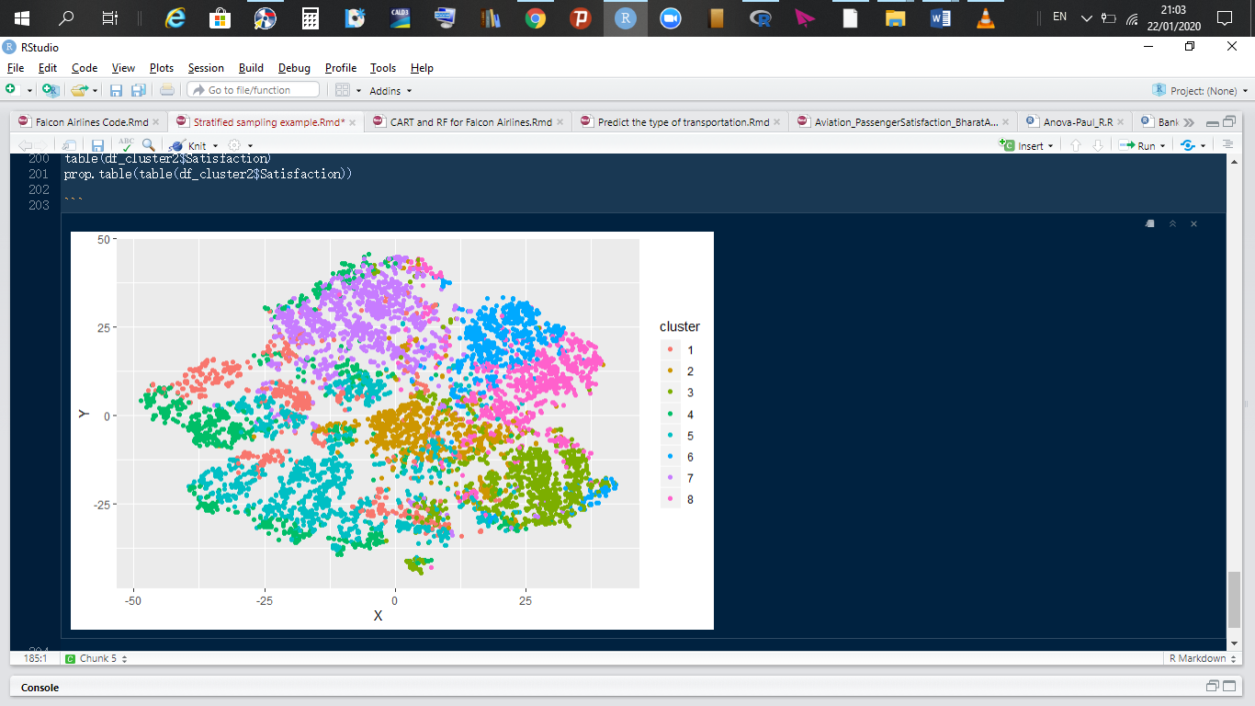

*Fig: Clients observed in a lower dimensional space*.

# **Summary of clusters**

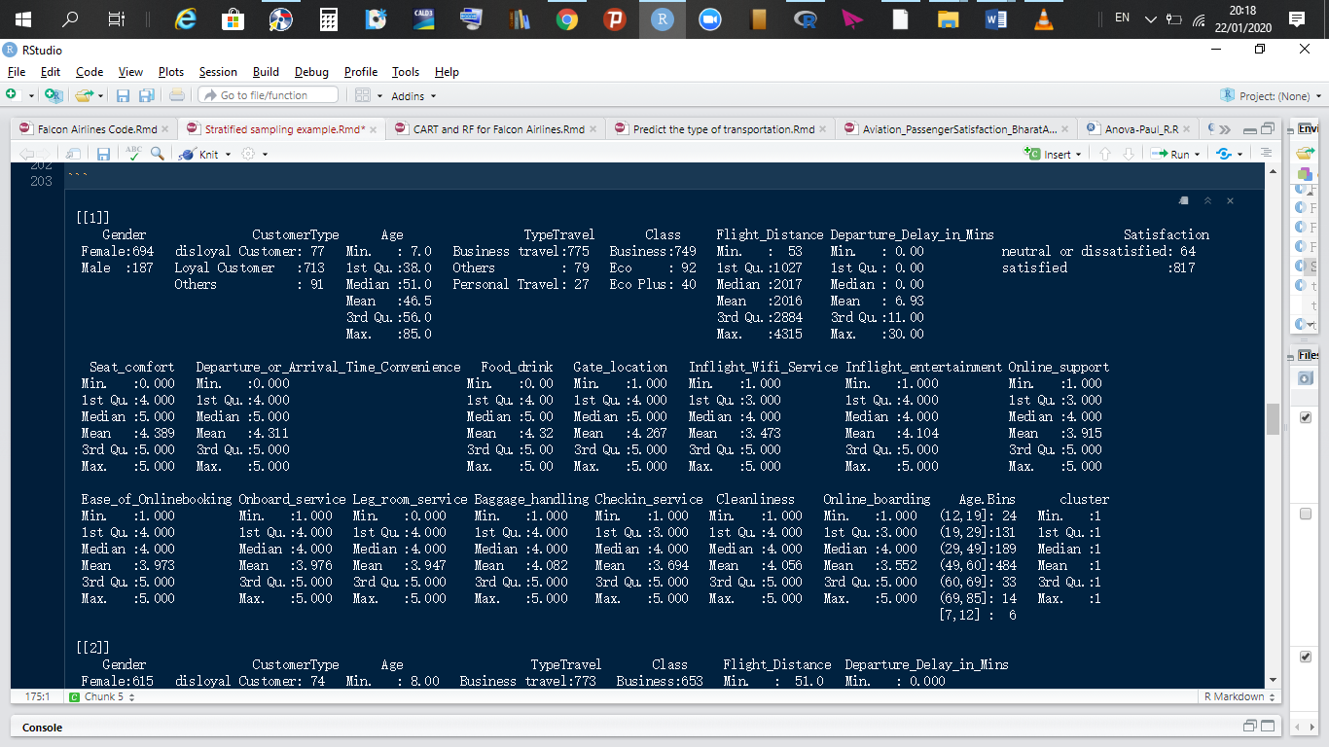

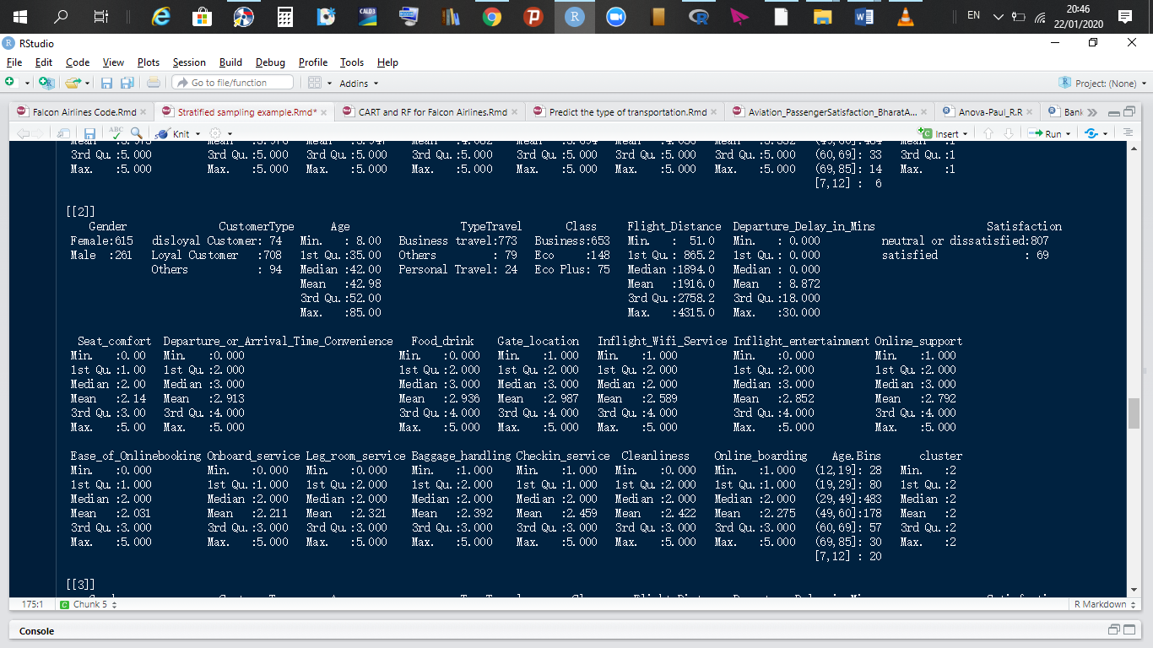

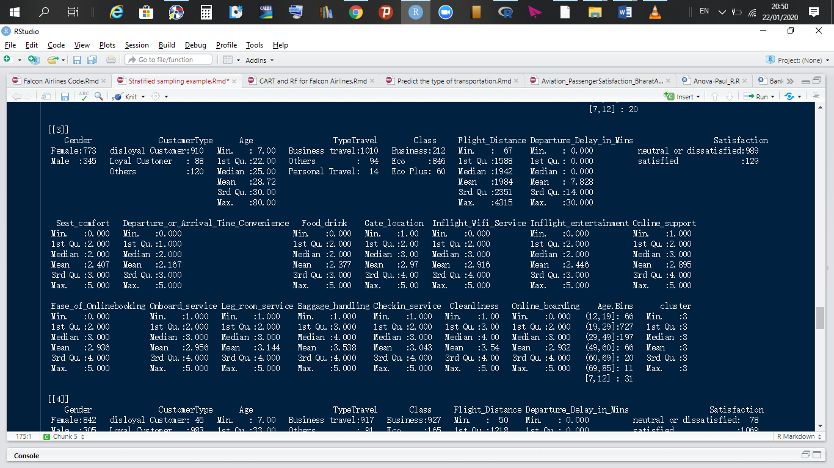

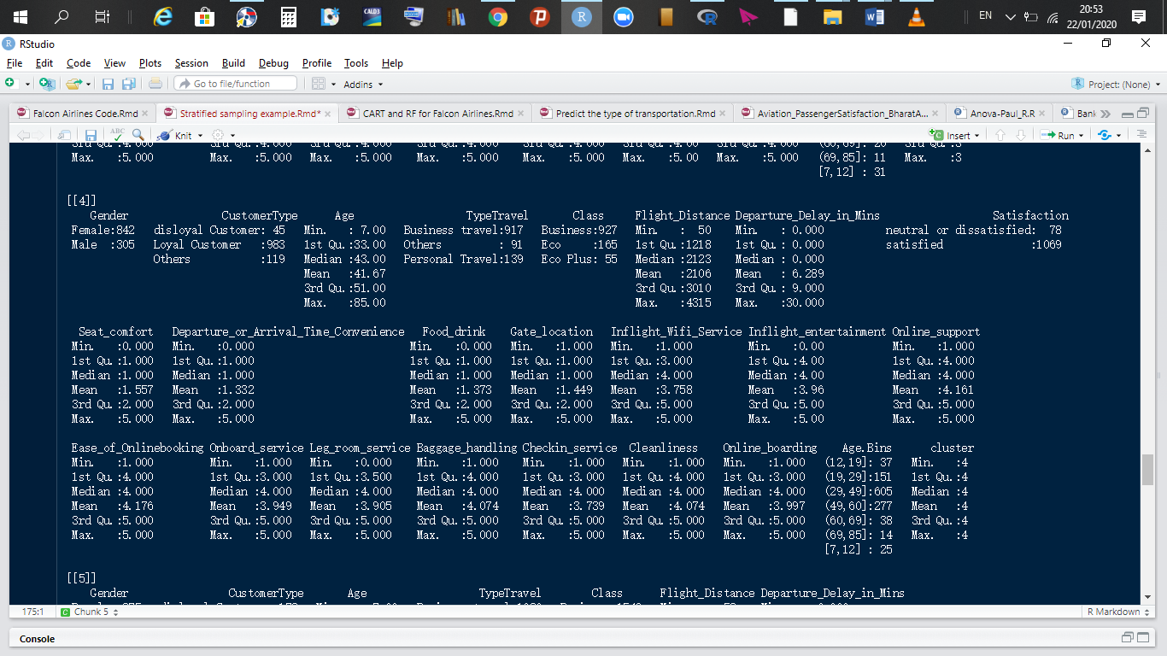

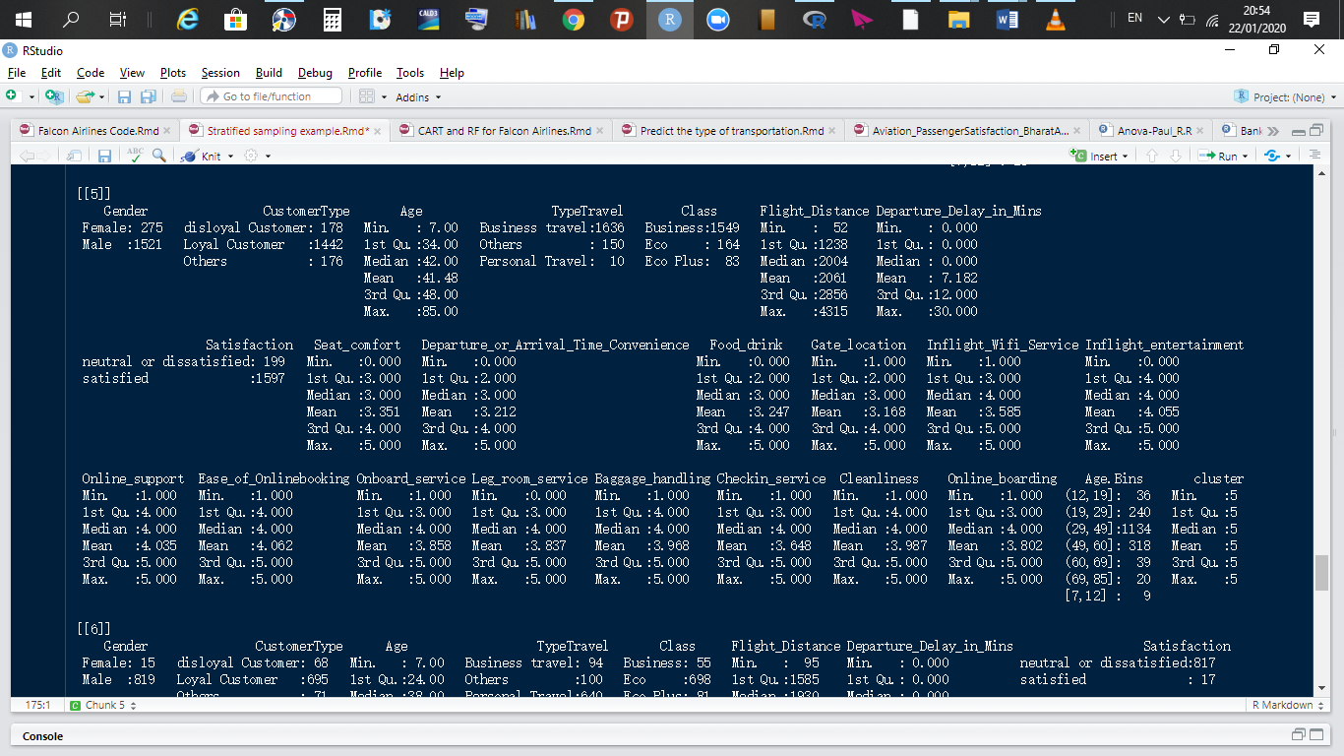

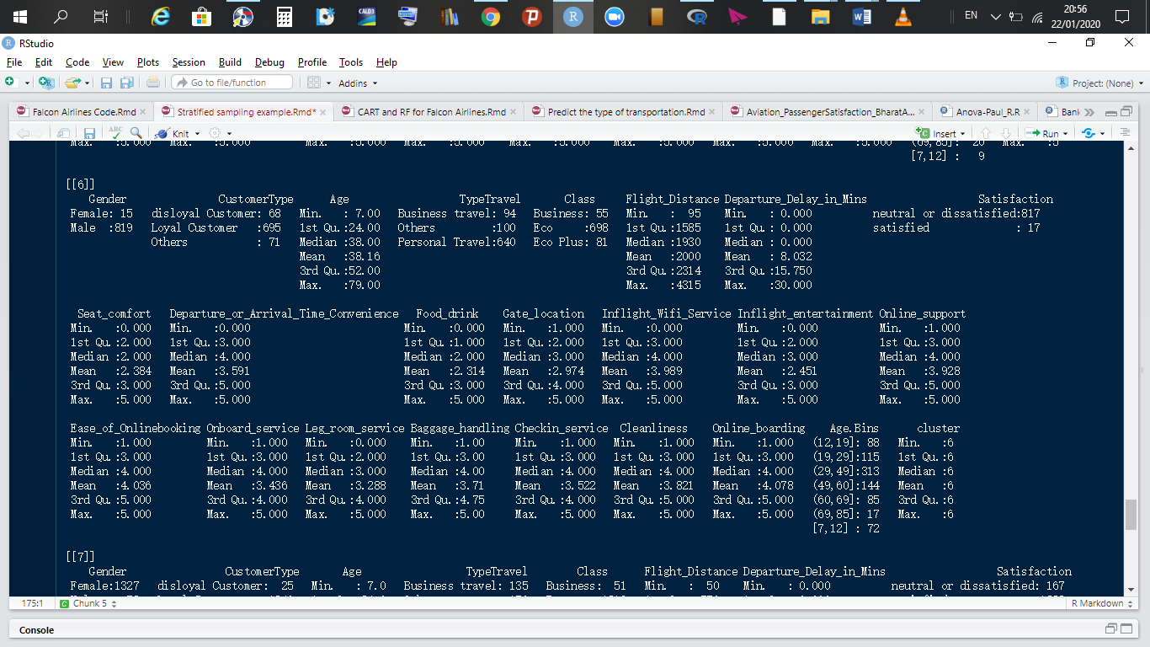

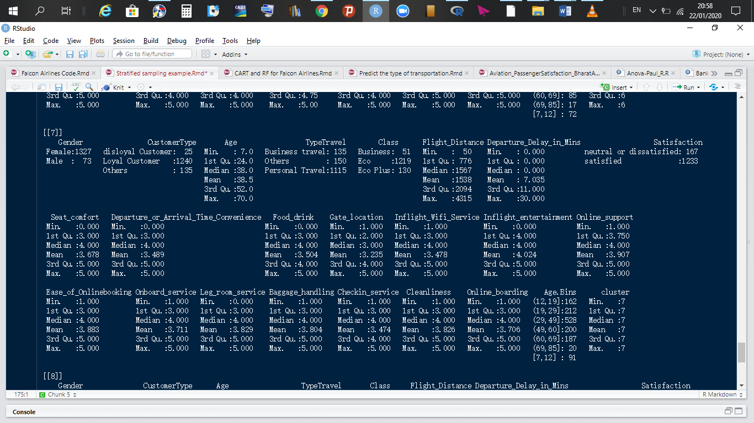

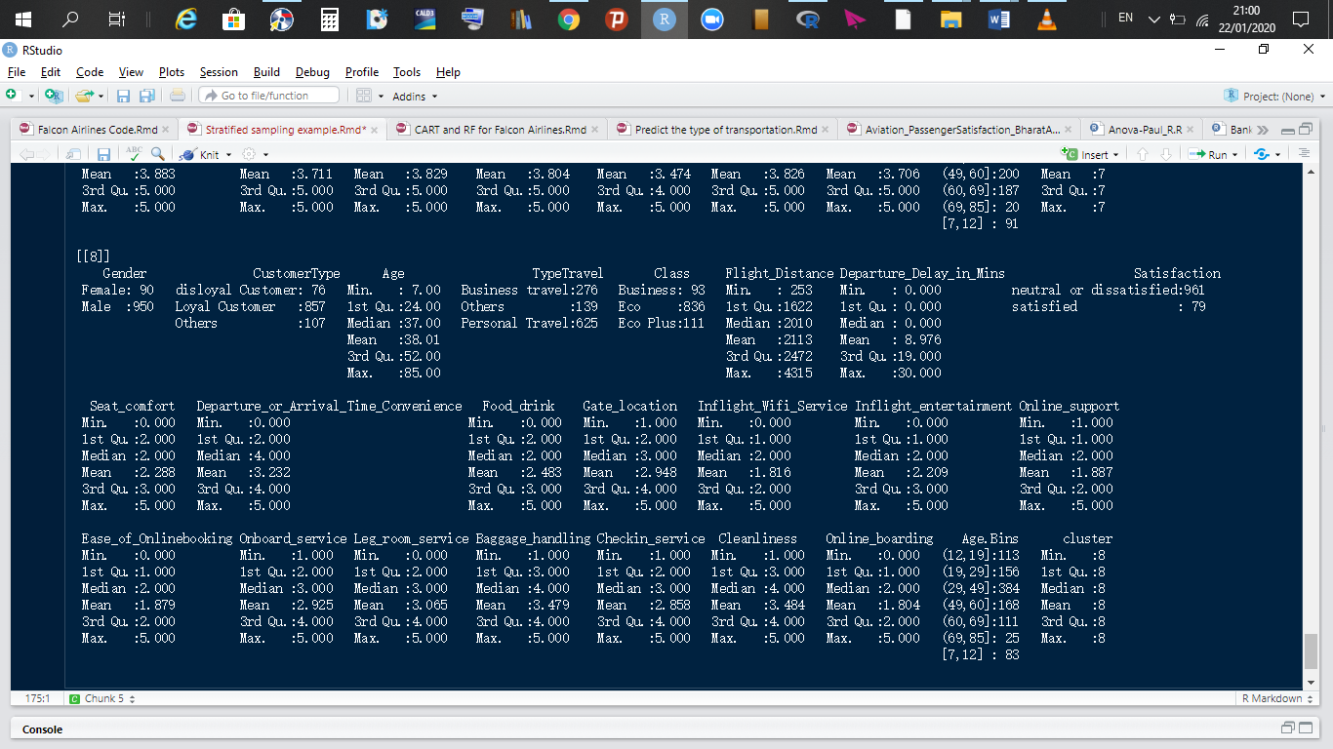

# **Random Forest Model**

Visualizing the out of bag error for our built random forest, the error rate plot w.r.t number of trees reveals that anything more than 490 trees is really not that valuable. In conclusion, we fine tune the number of trees, “ntree” parameter to 491.

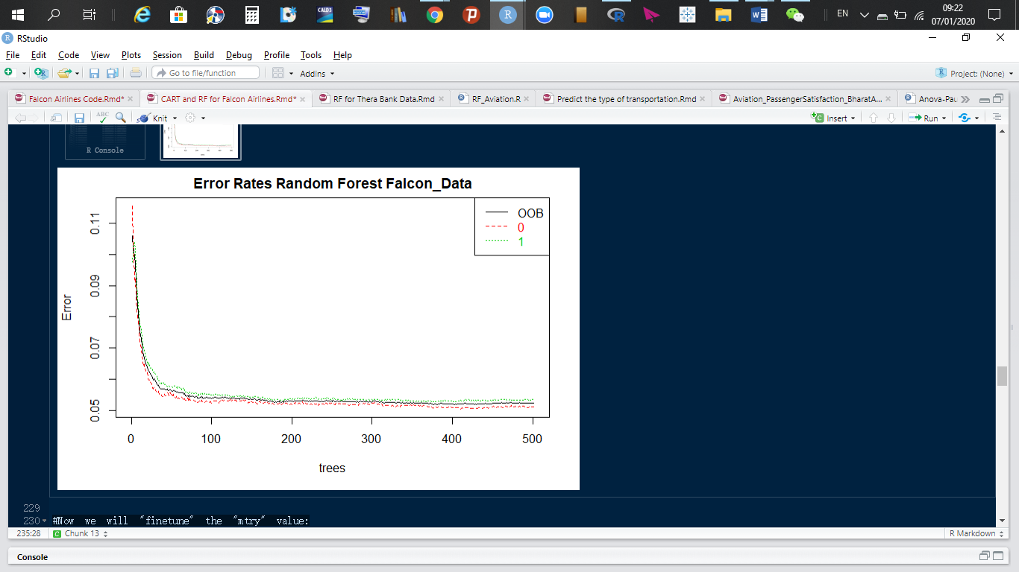

***Fig: Error rates for random forest.***

Next, we fine tune the number of splits from a node. “mtry”=13 was the value with the least number of out of bag errors as shown in the diagram below. Thus, the trees that do not contain the tested row had as error value 4.72% for “mtry”=13. Thus, our model gets better with the iterations we make.

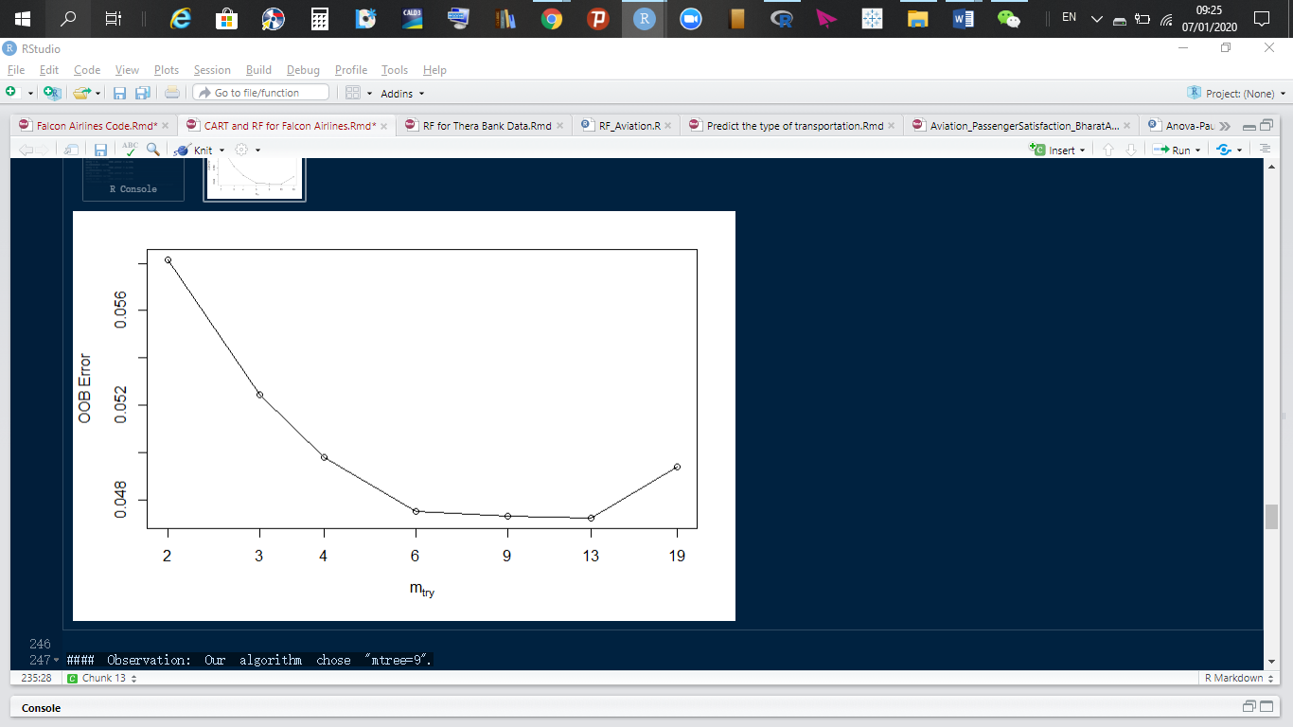

Our built random forest shows us how important each variable from the Falcon Airlines dataset is and shows us what variables are drivers for customer satisfaction.

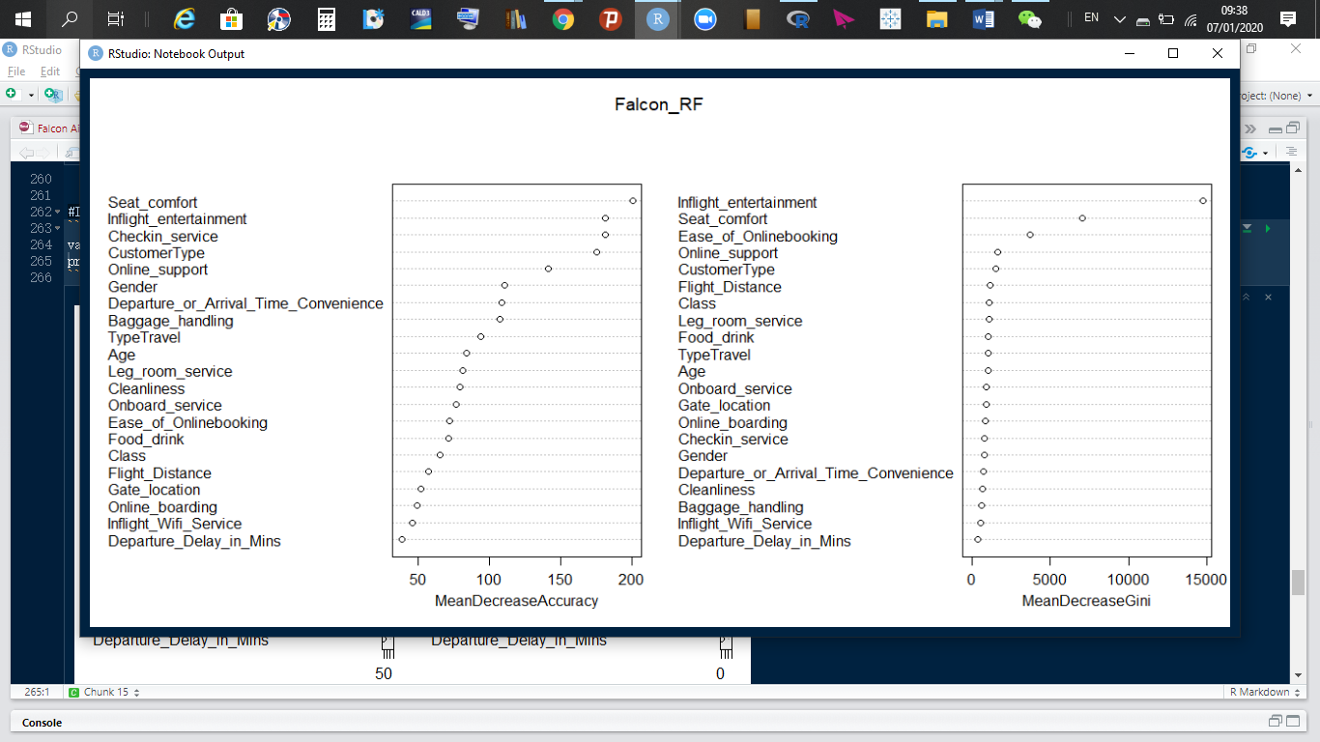

The MeanDecreaseGini is what we will consider for variable of importance. The above visual shows us that the top 4 variables responsible for customers to be satisfied with Falcon Airlines services are Inflight entertainment, seat comfort, ease of online booking, and online support. Similar to the results we got from our decision tree.

# **Model performance measures**

**Train data performance measures**

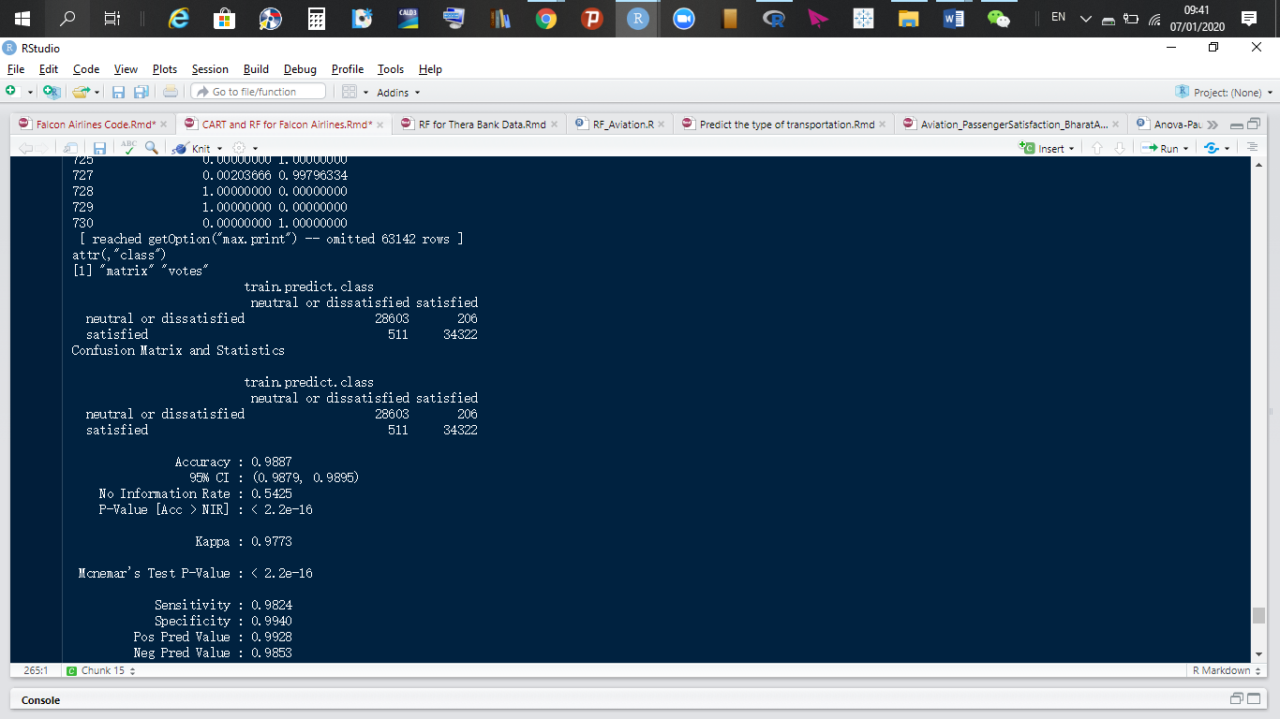

Our tree predicted that 28,603 customers will be dissatisfied and it turned out to match the actual. It also predicted 34,322 customers will be satisfied, which turned out to be true. Leading to an accuracy rate of 98.87%.

Our sensitivity rate is 98.24%; our model predicted 34,248 people will be satisfied after flying aboard Falcon Airlines and it was 98.24% correct.

Finally, our specificity rate is 99.40%, meaning the number of people predicted to be satisfied post flight but turned out they weren't was 206 and those predicted to have been dissatisfied but turned out they were actually satisfied was 511. These numbers are great. To validate them, we will run our model on our test data.

**Test data performance measures**

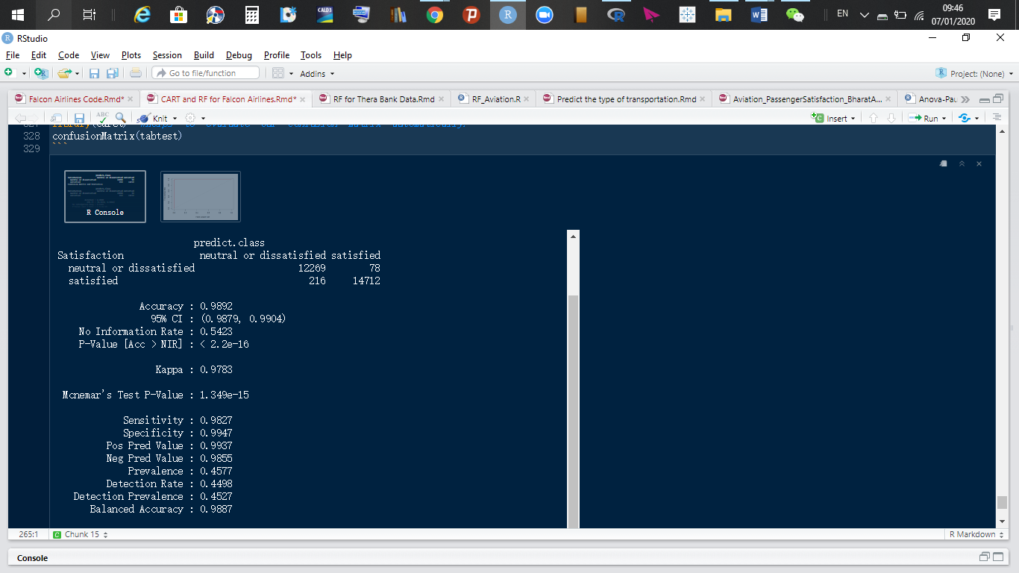

Our tree predicted that 12,269 customers will be dissatisfied and it turned out to match the actual. It also predicted 14,712 customers will be satisfied, which turned out to be true. Leading to an accuracy rate of 98.92%.

Our sensitivity rate is 98.27%; our model predicted 14,712 people will be satisfied after flying aboard Falcon Airlines and it was 98.27% correct.

Finally, our specificity rate is 99.47%, meaning the number of people predicted to be satisfied post flight but turned out they weren't was 78 and those predicted to have been dissatisfied but turned out they were actually satisfied was 216. Our random forest predicted accurately.

**Kolmogrorov-Smirnov Tests, Area under the curve and GINI**

**Train data:** The KS value is 97.95% and the area under the curve is 99.94%. Thus, high accuracy.

**Test data:** The KS value is 98.04% and the area under the curve is 99.94%. Thus, high accuracy.

|  |  |  |  |
| --- | --- | --- | --- |
| **Performance Measures for Random Forest Model** | | | |
| **Random Forest** | **Accuracy** | **Sensitivity** | **Specificity** |
| **Train data** | 98.87%. | 98.24% | 99.40% |
| **Test data** | 98.93%. | 98.01% | 99.71% |
| **Overfitting** | NO | NO | NO |
|  |  |  |  |
| **Random Forest** | **KS** | **AUC** |  |
| **Train data** | 97.95% | 99.94% |  |
| **Test data** | 98.04% | 99.94%. |  |

Our random forest model performed very well.

**Remarks on model validation exercise**

As a recap of the performance of our two models,

|  |  |  |  |
| --- | --- | --- | --- |
| **Performance Measures for CART Model** | | | |
| **Random Forest** | **Accuracy** | **Sensitivity** | **Specificity** |
| **Train data** | 85.91% | 87.46% | 84.80% |
| **Test data** | 86.17% | 87.36% | 85.31% |
| **Overfitting** | NO | NO | NO |
|  |  |  |  |
| **Random Forest** | **KS** | **AUC** |  |
| **Train data** | 70.86% | 88.93% |  |
| **Test data** | 71.48% | 89.06% |  |

|  |  |  |  |
| --- | --- | --- | --- |
| **Performance Measures for Random Forest Model** | | | |
| **Random Forest** | **Accuracy** | **Sensitivity** | **Specificity** |
| **Train data** | 98.87%. | 98.24% | 99.40% |
| **Test data** | 98.93%. | 98.01% | 99.71% |
| **Overfitting** | NO | NO | NO |
|  |  |  |  |
| **Random Forest** | **KS** | **AUC** |  |
| **Train data** | 97.95% | 99.94% |  |
| **Test data** | 98.04% | 99.94%. |  |

In conclusion,both models did not over fit. The test data performs well on both models. Based on the numbers for the KS and AUC values, we chose the random forest model for predicting which customers will be satisfied or not.

# **Recommendations for decision making**

Thus, the our most significant variables as printed by or tree which are responsible for customer satisfaction is Inflight entertainment, Ease of online booking, seat comfort, Food and drinks and online boarding. Based on the observations from our decision tree on page 62, the following recommendations are suggested for immediate implementation:

1. Improve entertainment for all classes of travel. Prior analysis revealed o us that younger customers and those between [70, 85] are very demanding on entertainment. Falcon Airlines should prepare various entertainment packages for all age groups.
2. Falcon Airlines can partner with the entertainment industry to share some useful intelligence on what the various age demographics care about.
3. Falcon Airlines should make online booking such that it is perceived as easy by the customers.
4. Falcon Airlines should make the online booking technology user friendly.
5. Seat comfort should be improved for economic and economic pro class since prior analysis showed they are not happy with the seat comfort, especially among [20, 29] and [70, 85] age groups.
6. Seat comfort should be improved on Falcon Airlines’ aircrafts.
7. The technology used by Falcon Airlines should be user friendly and also online support should be very effective.

Segmentation will help us know how to best serve our clients. As a result of this, the following customer profile was revealed to us by our clustering algorithm summary of clusters:

|  |  |  |  |  |  |  |
| --- | --- | --- | --- | --- | --- | --- |
| Clusters | Gender | Customer Type | Type Travel | Class | Satisfaction | Age Bins |
| 1 | Female | Loyal customers | Business travel | Business | Satisfied | (49,60] |
| 2 | Female | Loyal customers | Business travel | Business | Dissatisfied | (29,49] |
| 3 | Female | Disloyal | Business travel | Eco | Dissatisfied | (19,29] |
| 4 | Female | Loyal | Business travel | Business | Satisfied | (29,49] |
| 5 | Male | Loyal customers | Business travel | Business | Satisfied | (29,49] |
| 6 | Male | Loyal customers | Personal travel | Eco | Dissatisfied | (29,49] |
| 7 | Female | Loyal customers | Personal travel | Eco | Satisfied | (29,49] |
| 8 | Male | Loyal customers | Personal travel | Eco | Dissatisfied | (29,49] |

As a brief recap of this table can be referred to on page 71. Also, on page 25, we see that the age groups (29, 49], (49, 60] and (19, 29] are the most populous and from our clusters’ profiling, we see that age groups (29, 49] and (19, 29] are populated with unsatisfied customers. These customers travel for personal reasons, travel with Eco class and are mostly unsatisfied. This findings are consistent with those found pages 32. On page 33, we see a record number dissatisfied customers travelling using Eco class.

On page 35, people who travel for very long number of miles prefer to use business class. On page 38, age group (19, 29] contains the most disloyal customers and our clustering profiling tells us they mostly travel using business class. On page 45, disloyal customers are of the opinion that, departure or arrival time convenience needs improvement.

**Recommendations:**

* More specified support for younger customers; both company personnel and flight attendants should be more patient with young customers.
* Wi-Fi service aboard aircrafts should be enhanced and improved for all classes.
* If possible, gate location should be shortened, food and drinks should be improved. Addition of more food and drinks options should be included to the existing menu.
* Check-in service should be improved as well.
* More specified services or directions on the company’s website or mobile application should be provided to help assist customers.
* More tailored services for younger customers.
* Leg room service should be improved for their aircrafts in general. Age groups [70, 85] and [13, 29] could be suggested particular seats on-board to enhance satisfaction.

On page 49, Check-in services, leg room services, onboard service, online support and online boarding were all rated as “good” for Business class passengers and rated as “acceptable” Eco Plus and Eco passengers.

**Recommendation:**

* Improve this for Eco Plus and Eco passengers based on the variables of importance as printed by our random forest.

Business class travelers on average travel longer distances than other classes as shown on page 41 and they are made up of mostly younger customers: [7, 12], (12, 19], (19, 29], and (29, 49. These customers are more demanding leg room service, onboard service, food and drinks and gate location.

**Recommendation**

* Training of air hostesses and improvement of fate location.
* Add more options for customers to select when it comes to Food and drinks

**Cleanliness:** A growing percentage of customers think or are of the opinion that the aircrafts need improvement with respect to cleanliness and others think that cleanliness is poor.

**Recommendation:**

* Falcon Airlines should continuously monitor the state of aircrafts and ensure it is always very clean, from the floor, to chairs to the bathrooms.

Departure or arrival time convenience was observed to sway customers’ satisfaction to dissatisfaction on page 22 and 23. Also, on page 54, we see clearly that ratings are slightly affected by delays in departures and arrivals.

**Recommendation:**

* Effective communication: the Falcon Airlines’ communication team should keep customers updated on every detail of importance of travel to customers.

Above all, the employees of Falcon Airlines should be trained how to better serve customers and should be given a clear picture of how customer satisfaction is linked to the creation of wealth for Falcon Airlines and how critical customer satisfaction is import for every organization as outlined in the qualitative research.

# **3.3 References**

(1) Duncan T. (2005). Principles of advertising & IMC. Boston, Massachusetts: McGraw-Hill.

(2) Petrick, J. F. (2002). Development of a multi-dimensional scale for measuring the perceived value of a service. Journal of Leisure Research, 34(2), 119–134.

(3) Johnson, WC, & Weinstein, A. (2004). Delivering superior customer value in the new economy: Concepts and cases, 2.

(4) Kerin, RA, Hartley, SW, & Rudelius W. (2009). Boston, Massachusetts: McGraw-Hill Higher Education.

(5) Jessica M. Bailey, Claudette Chin-Loy, Nikolaos Karagiannis, & Zagros Madjd-Sadjadi (2007) [J], Journal of Applied Management and Entrepreneurship, 17(1):120-123.

(6) McFarlane, DA and Britt, MM (2007), “Publix Supermarkets: A Company Analysis for Global Business” [J], Business Journal for Entrepreneurs, 4, 44-53.

(7) McFarlane, DA, Britt, MM, Weinstein, A and Johnson WC. (2007). “Managing eservice quality and customer relationships in the new economy”, Conference Proceedings for Society of Marketing Advances [M]: San Antonio, Texas.

(8) Mujtaba, BG and McFarlane, DA (2007). “Virtual performance management and information technology in the twenty-first century workplace” in Chin-Loy, C., Karagiannis, N. and Madjid-Sadjadi, Z (eds.) [M], Modern competitiveness in the twenty-first century. Lanham, Maryland: Lexington Books, 147-164.

(9) Mujtaba, BG., & McFarlane, DA. (2007). “Competitive advantage and market organizations in the 21st century: Market driving or market driven?” in Farazmand, A and Pinkowski, J (eds.) [M], Handbook of globalization, governance and public administration. Boca Raton, Florida: CRC Press-Francis & Taylor Group, 981 -1002.

(10) Parasuraman, A, Zeithaml, V and Berry, L. (1985) “A conceptual model of service quality and its implications for future research”, [J] Journal of Marketing 3, 41-50.

(11) Parasuraman, A, Zeithaml, V and Berry, L. (1985) “Communication and control processes in the delivery of service quality” [J], Journal of Marketing, 4, 35-48.

(12) Pohlman, RA and Gardiner, GS. (2000). Value driven management: How to create and maximize value over time for organizational success. New York, NY: American Management Association.

(13) Reicheld, F and Sasser, WE, Jr. (1990) “Zero defections: Quality comes to services” [J], Harvard Business Review, 68 (5), pp. 105-111.

(14) Solomon, MR. (2004). Consumer behavior: Buying, having, and being. 6th Ed [M]. Upper Saddle River, New Jersey: Prentice Hall.

(15) Weinstein, A, (2012). Superior customer value: Strategies for winning and retaining customers. 3rd Ed [M]. Boca Raton, Florida: CRC Press-Taylor & Francis Group.

(16) Zeithaml, V, Parasuraman, A. and Berry, L. (1990). Delivering service quality: Balancing customer perceptions and expectations. New York, NY: The Free Press.

(17) Flint, D.J., Woodruff, R.B., Gardial, SF. (1997). Customer value change in industrial marketing relationships: a call for new strategies and research. [J] Industrial Marketing Management, 26 (2), 163–175.

(18) Huber, F., Herrmann, A., Morgan, R.E. (2010). Gaining competitive advantage through customer value oriented management [J]. Journal of Consumer Marketing 18 (1), 41–53.

(19) Liu, A.H., Leach, M.P., Bernhardt, K.L. (2005). Examining customer value perceptions of organizational buyers when sourcing from multiple vendors [J]. Journal of Business Research, 58 (5), 559–568.

(20) McDougall, G.H.G., Leveque, & T. (2000). Customer satisfaction with services: putting perceived value into the equation [J]. Journal of Services Marketing, 14 (5), 392–410.

(21) Petrick, J.F. (2002). Development of a multi-dimensional scale for measuring the perceived value a service [J]. Journal of Leisure Research, 34 (2), 119–134.

(22) Ulaga, W., Chacour, S. (2001). Measuring customer-perceived value in business markets [J]. Industrial Marketing Management, 30 (6), 525–540.

(23) Walter, A., Ritter, T., Gumenden, H.G. (2001). Value creation in buyer–seller relationships: theoretical considerations and empirical results from a supplier’s perspective [J]. Industrial Marketing Management, 30 (4), 365–377.

(24) Weinstein, A., Pohlman, R.A. (1998). Customer value: a new paradigm for marketing management [M]. Advance in Business Studies, 6 (10), 89–97.

(25) Woodruff, R. (1997). Customer value: the next sources for competitive advantage [J]. Journal of the Academy of Marketing Science, 25 (2), 17–23.

(26) Zeithaml, V.A. (1988). Consumer perceptions of price, quality, and value: a means-end model and synthesis of evidence [J]. Journal of Marketing, 52 (3), 2–22.

(27) Sweeney, J.C., Soutar, G.N. (2001). Consumer perceived value: the development of a multiple item scale [J]. Journal of Retailing, 77 (2), 203–220.

(28) Slater, S.F. (2012). Developing a customer value-based theory of the firm [J]. Journal of the Academy of Marketing Science 25 (2), 162–167.

(29) Slater, S.F., Narver, J.C. (2000). Intelligence generation and superior customer value [J]. Journal of Academy of Marketing Science, 28 (1), 120–127.

(30) Spiteri, J.M., Dion, P.A. (2004). Customer value, overall satisfaction, end-user loyalty, and market performance in detail intensive industries [J]. Industrial Marketing Management, 33 (8), 675–687.

(31) <https://www.youtube.com/watch?v=An7nPLJ0fsg>

(32) <https://towardsdatascience.com/clustering-on-mixed-type-data-8bbd0a2569c3>

(33) <https://towardsdatascience.com/stratified-sampling-and-how-to-perform-it-in-r-8b753efde1ef>